Suzuki DRZ400S Parts list

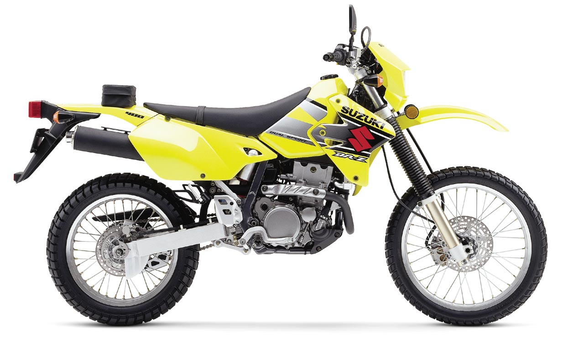

Contents

1 Engine – Top End 4
1.1 Cylinder 6
1.2 Cylinder head 7
1.3 Cylinder head cover 6
1.4 Cam chain 13
1.5 Cam shaft valves 7
1.6 Radiator fan 15
1.7 Radiator 16
2 Engine – Bottom End 18
2.1 Crankcase cover 18
2.2 Crankcase 20
2.3 Clutch 22
2.4 Magnets 25
2.5 Crank balancer 26
2.6 Crankshaft 28
2.7 Gear shifting 31
2.8 Transmission 33
2.9 Water pump 35
2.10 Oil pump 37
2.11 Oil hose 39
2.12 Starter clutch 41
2.13 Starting motor 43
3 Electrical 45
3.1 Battery 45
3.2 Electrical 47
3.3 Wiring harness 49
3.4 Turn signal lamp 51
3.5 Tail lamp 53
3.6 Headlamp 55
4 Fuel 57
4.1 Air cleaner 57
4.2 Carburetor 59
4.3 Fuel cock 62
4.4 Fuel tank 63
4.5 Pair system 65
5 Frame 67
5.1 Frame 67
5.2 Frame cover 69
5.3 Seat 70
5.4 Stand 71
5.5 Muffler 73
5.6 Rear fender 75
6 Front 77
6.1 Front caliper 77
6.2 Front master cylinder 80
6.3 Front fork bracket 82
6.4 Front fork damper 84
6.5 Front wheel 86
7 Rear 88
7.1 Rear caliper 88
7.2 Rear master cylinder 90
7.3 Rear brake 92
7.4 Rear cushion lever 93
7.5 Rear shock absorber 95
7.6 Rear swing arm 97
7.7 Rear wheel 99
8 Cockpit 101
8.1 Speedometer 101
8.2 Handle switch 103
8.3 Handlebar 104
8.4 Left handle lever 106
8.5 Right handle lever 107
9 Other 108
9.1 Gasket set 108
9.2 Label 109
9.3 Optional 111

Torque specification
Torque in Newton-meter (Nm)

Engine
Cylinder head cover bolts | 14
Spark plug | 11
Cylinder head bolts, 6 mm OD | 10
Cylinder head bolts, 10 mm OD | 46
Cylinder head side bolt | 14
Cylinder nut | 10
Decompression shaft bolt | 10
Decompression lever nut | 23
Camshaft holder bolts | 10
Balancer shaft nut | 50
Primary drive gear nut | 110
Flywheel rotor nut | 100
Clutch hub nut | 70
Gearshift arm stopper | 19
Gearshift cam driven gear bolt | 24
Cam chain tensioner spring bolt | 8
Crankcase engine oil drain plug | 21
Frame engine oil drain plug | 18
Crankcase bolts | 11
Oil strainer | 23
Oil hose banjo bolts | 23
Radiator air bleed bolt | 6
Timing inspection plug | 23
Engine mounting nuts | 66
Engine mounting bracket nuts | 40
Exhaust pipe bolts and nuts | 23
Muffler bolts | 23
Engine sprocket nut | 110

Chassis
Handlebar clamp pinch bolts | 23
Upper triple clamp pinch bolts | 30
Lower triple clamp pinch bolts | 32
Steering stem head nut | 90
Fork cap bolts | 23
Fork damper rod bolts | 80
Fork inner rod lock nut | 22
Master cylinder mounting bolts | 10
Brake hose banjo bolts | 23
Front brake caliper mounting bolts | 26
Brake pad mounting pin | 18
Brake caliper bleeder valves | 7.5
Rear brake pedal bolt | 29
Brake disc bolts | 10
Front axle nut | 42
Front axle pinch bolt | 18
Seat rail mounting nuts, upper | 35
Seat rail mounting bolts, lower | 35
Rear axle nut | 110
Rear sprocket nuts | 30
Drive chain roller bolts | 40
Swing arm pivot nut | 77
Shock absorber compression damper | 30
Shock absorber spring preload lock nut | 90
Rear suspension rocker arm pivot | 100
Rear suspension tie rods | 100
Side stand bolt | 50
Side stand nut | 55

Engine – Top End

Cylinder head cover
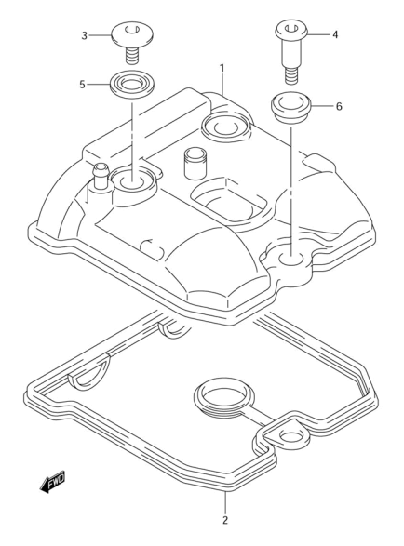
Ref | Description | Qty | SKU | Price (inc vat)
1 | Cover, Cylinder Head | 1 | 1117029F00 | € 482,50
2 | Gasket | 1 | 1117329F00 | € 33,45
3 | Bolt (7X17.5) | 2 | 0910607009A08 | € 5,54
4 | Bolt (L:19) 5X10 | 1 | 0910607010 | € 5,74
5 | Washer | 2 | 1119127E00 | € 5,06
6 | Cushion, Head Cover Bolt | 1 | 1119213E00 | € 5,06

Cam shaft valves
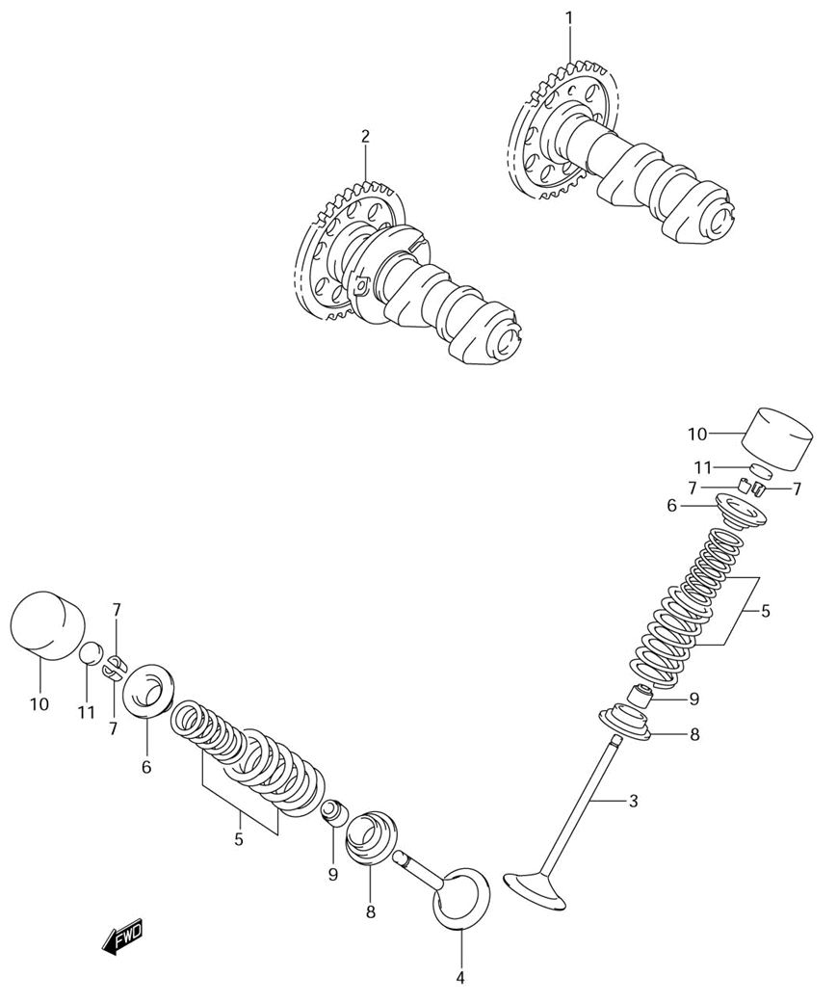

Ref | Description | Qty | SKU | Price (inc vat)
1 | Camshaft | 1 | 1271029F10 | € 318,39
2 | Camshaft | 1 | 1272029F21 | € 580,99
3 | Valve, Intake | 2 | 1291129F00 | € 38,40
4 | Valve, Exhaust | 2 | 1291229F00 | € 63,28
5 | Spring Set, Valve | 4 | 1292029F00 | € 18,87
6 | Retainer, Valve Spring | 4 | 1293102F10 | € 17,85
7 | Cotter, Valve | 8 | 1293224F00 | € 2,36
8 | Seat, Valve Spring | 4 | 1293338400 | € 6,45
9 | Oil Seal | 4 | 0928905011 | € 7,79
10 | Tappet | 4 | 1289102F00 | € 60,08
11 | Shim, Tappet (T:2.30) | 4 | 1289241C00230 | € 10,33
11 | Shim, Tappet (T:2.35) | 4 | 1289241C00235 | € 10,33
11 | Shim, Tappet (T:2.40) | 4 | 1289241C00240 | € 10,33
11 | Shim, Tappet (T:2.45) | 4 | 1289241C00245 | € 10,33
11 | Shim, Tappet (T:2.50) | 4 | 1289241C00250 | € 10,33
11 | Shim, Tappet (T:2.55) | 4 | 1289241C00255 | € 10,33
11 | Shim, Tappet (T:2.60) | 4 | 1289241C00260 | € 10,33
11 | Shim, Tappet (T:2.65) | 4 | 1289241C00265 | € 10,25
11 | Shim, Tappet (T:2.70) | 4 | 1289241C00270 | € 10,33
11 | Shim, Tappet (T:2.75) | 4 | 1289241C00275 | € 10,33
11 | Shim, Tappet (T:2.80) | 4 | 1289241C00280 | € 10,33
11 | Shim, Tappet (T:2.85) | 4 | 1289241C00285 | € 10,33
11 | Shim, Tappet (T:2.90) | 4 | 1289241C00290 | € 10,33
11 | Shim, Tappet (T:2.95) | 4 | 1289241C00295 | € 10,33
11 | Shim, Tappet (T:3.00) | 4 | 1289241C00300 | € 10,33
11 | Shim, Tappet (T:3.05) | 4 | 1289241C00305 | € 10,33
11 | Shim, Tappet (T:3.10) | 4 | 1289241C00310 | € 10,33
11 | Shim, Tappet (T:3.15) | 4 | 1289241C00315 | € 10,33
11 | Shim, Tappet (T:3.20) | 4 | 1289241C00320 | € 10,33
11 | Shim, Tappet (T:3.25) | 4 | 1289241C00325 | € 10,33
11 | Shim, Tappet (T:3.30) | 4 | 1289241C00330 | € 10,33
11 | Shim, Tappet (T:3.35) | 4 | 1289241C00335 | € 10,33
11 | Shim, Tappet (T:3.40) | 4 | 1289241C00340 | € 10,33
11 | Shim, Tappet (T:3.45) | 4 | 1289241C00345 | € 10,33
11 | Shim, Tappet (T:3.50) | 4 | 1289241C00350 | € 10,33

Cylinder head
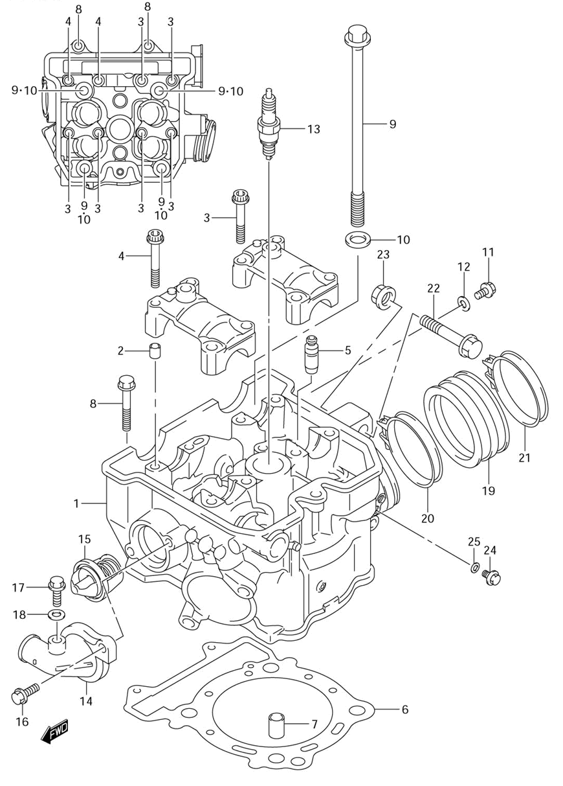
Ref | Description | Qty | SKU | Price (inc vat)
1 | Head Assy, Cylinder | 1 | 1110029F21 | € 1.486,53
2 | Pin | 4 | 0920608001 | € 2,06
3 | Bolt | 6 | 071200640B | € 4,18
4 | Bolt | 2 | 071200645B | € 4,18
5 | Guide, Valve (0S:0.3) | 4 | 1111520E70 | € 33,34
6 | Gasket, Cylinder Head | 1 | 1114129F01 | € 46,65
7 | Pin 13X18 | 2 | 0421113189 | € 2,66
8 | Bolt (6X39) | 2 | 0910306504 | € 3,30
9 | Bolt (10X175) | 4 | 0910310276 | € 19,72
10 | Washer 10.5X19X | 4 | 0916010082 | € 1,94
11 | Bolt | 1 | 015500610B | € 2,89
12 | Gasket | 1 | 0916806023 | € 2,47
13 | Spark Plug (Ngk,Cr8E) | 1 | 0948200456 | € 11,23
13 | Spark Plug (Nd,U24Esr-N) | 1 | 0948200457A00 | € -
13 | Spark Plug (Ngk,Cr9E) | 1 | 0948200458 | € 12,92
13 | Spark Plug (Nd,U27Esr-N) | 1 | 0948200459A00 | € -
13 | Spark Plug (Ngk,Cr10E) | 1 | 0948200460 | € 13,56
13 | Spark Plug (Nd,U31Esr-N) | 1 | 0948200461 | € 13,56
13 | Spark Plug (Denso,U22Esr-N) | 1 | 0948200515 | € 12,92
13 | Spark Plug (Ngk,Cr7E) | 1 | 0948200516 | € 12,92
14 | Cover, Thermostat | 1 | 1766129F10 | € 42,26
15 | Thermostat, Water | 1 | 1767033400 | € 40,92
16 | Bolt | 2 | 015470616B | € 2,99
17 | Plug | 1 | 1756850F00 | € 4,62
18 | Gasket | 1 | 0916806026 | € 3,88
19 | Pipe, Intake | 1 | 1311129F10 | € 22,49
21 | Clamp | 1 | 0940252208 | € 6,77
22 | Bolt (10X50) | 1 | 0910310235 | € 6,08
23 | Nut | 1 | 0915910115 | € 4,29
24 | Bolt, Oil Gallery In | 2 | 0910308335 | € 2,93
25 | Gasket | 3 | 0916808016 | € 2,02

Cylinder
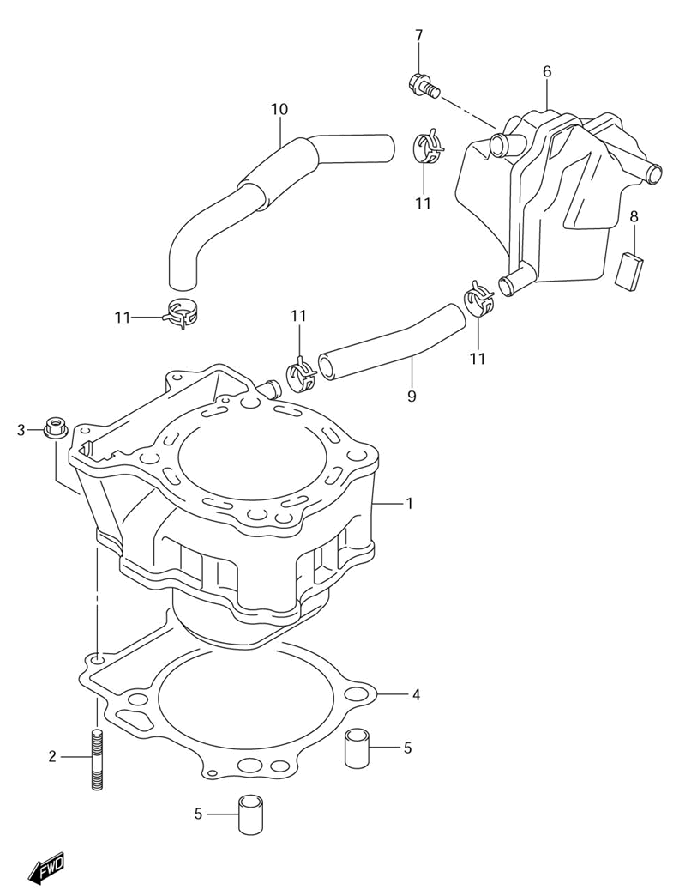

Ref | Description | Qty | SKU | Price (inc vat)
1 | Cylinder | 1 | 1121029F200F0 | € 662,20
2 | Stud Bolt | 2 | 014210625B | € 3,41
3 | Nut | 2 | 083161006B | € 2,93
4 | Gasket, Cylinder | 1 | 1124129F11 | € 26,10
5 | Pin 13X18 | 2 | 0421113189 | € 2,66
6 | Tank, Oil Return | 1 | 1133029F00 | € 51,55
7 | Bolt | 1 | 015500610A | € 1,90
8 | Protector (170X95X3.0) | 1 | 3365137000 | € 5,65
9 | Hose, Breather | 1 | 1133229F00 | € 12,49
10 | Hose, Breather | 1 | 1133329F00 | € 25,06
11 | Clip | 4 | 0940115404 | € 2,80

Cam chain
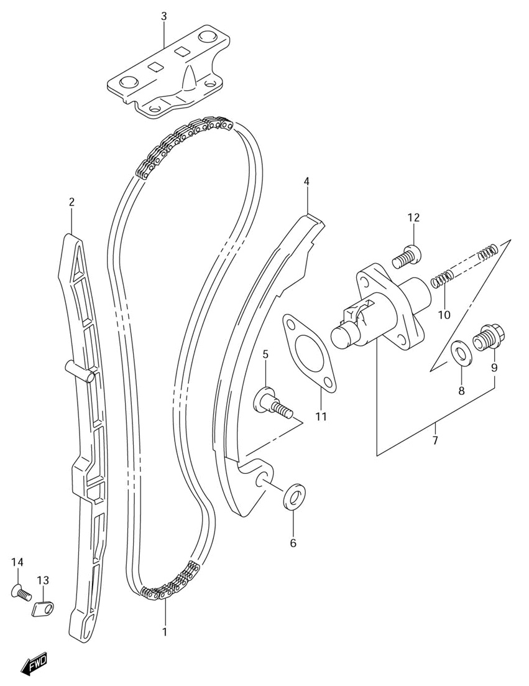

Ref | Description | Qty | SKU | Price (inc vat)
1 | Chain, Cam Shaft Drive | 1 | 1276029F01 | € 112,34
2 | Guide, Cam Chain No.1 | 1 | 1277129F00 | € 34,94
3 | Guide, Cam Chain No.2 | 1 | 1278229F00 | € 26,69
4 | Tensioner, Cam Chain | 1 | 1281129F10 | € 53,86
5 | Bolt, Cam Chain Tensioner | 1 | 1281235C00 | € 10,23
6 | Washer | 1 | 0821106181 | € 2,50
7 | Adjuster Assy, Tensioner | 1 | 1283029F10 | € 132,33
8 | Gasket | 1 | 1283724F10 | € 5,66
9 | Plug | 1 | 1283305A00 | € 14,41
10 | Spring | 1 | 1283139F00 | € 5,18
11 | Gasket, Adjuster | 1 | 1283724A10 | € 4,14
12 | Bolt | 2 | 071300625B | € 3,56
13 | Retainer, Cam Chain Guide No.1 | 1 | 1277324F00 | € 3,03
14 | Screw, Drive Shaft (6X12) | 1 | 0912606011 | € 2,40

Radiator fan
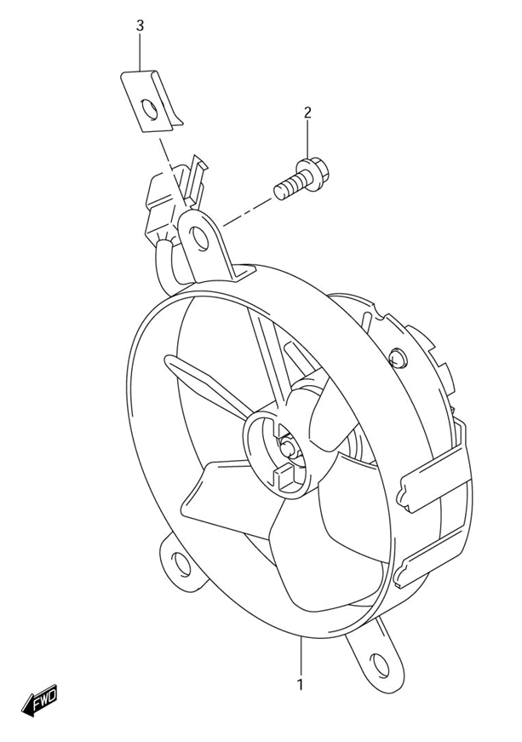
Ref | Description | Qty | SKU | Price (inc vat)
1 | Fan Assy, Radiator | 1 | 1780029F01 | € 533,41
2 | Bolt | 3 | 015500610B | € 2,89
3 | Nut, Fan Assy | 3 | 0914806015 | € 3,56

Radiator
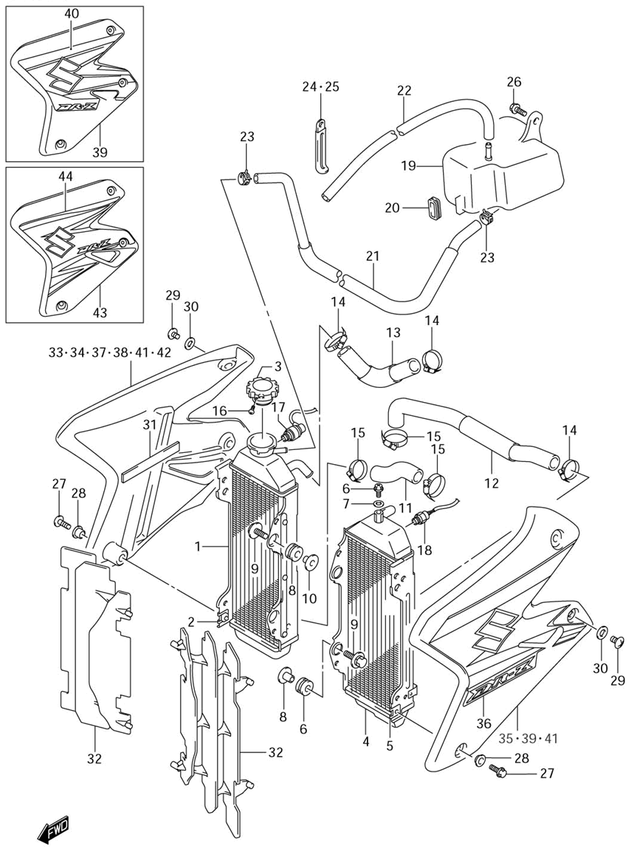

Ref | Description | Qty | SKU | Price (inc vat)
1 | Radiator, RH | 1 | 1771029F11 | € 596,44
2 | Nut, Fan Assy | 1 | 0914806015 | € 3,56
3 | Cap, Radiator | 1 | 1773019D11 | € 50,17
4 | Radiator, LH | 1 | 1772029F12 | € 617,90
5 | Nut, Fan Assy | 1 | 0914806015 | € 3,56
6 | Plug | 1 | 1756850F00 | € 4,62
7 | Gasket | 1 | 0916806026 | € 3,88
8 | Cushion, Radiator Upper | 4 | 1778719A00 | € 3,34
9 | Bolt (6X25) | 4 | 0911606147 | € 4,71
10 | Spacer | 4 | 0918006243 | € 6,61
11 | Hose, Inlet | 1 | 1785129F10 | € 16,10
12 | Hose, Outlet | 1 | 1785229F30 | € 48,38
13 | Hose, Joint | 1 | 1785329F10 | € 25,49
14 | Clamp | 3 | 0940228513 | € 8,50
15 | Clamp | 3 | 0940232512 | € 12,95
16 | Screw, Radiator Cap | 1 | 1773303D10 | € 2,70
17 | Switch, Water Temperature | 1 | 3485003D00 | € 115,54
18 | Switch, Fan | 1 | 1768024A30 | € 123,48
19 | Tank, Reservoir | 1 | 1791129F11 | € 58,56
20 | Cushion, Reservoir Tank | 1 | 1791329F00 | € 4,25
21 | Hose, Inlet | 1 | 1798129F01 | € 20,24
22 | Hose 5X9X2000 | 1 | 093525090100B | € 28,79
23 | Clip | 2 | 0940108411 | € 1,56
24 | Clamp(L:45 T:0.6) | 1 | 0940408205 | € 3,67
25 | Clamp | 1 | 0940406429 | € 2,06
26 | Bolt, Bracket | 1 | 015500612B | € 2,89
27 | Screw | 2 | 0214206163 | € 2,63
28 | Washer | 2 | 0916906060 | € 2,61
29 | Screw | 4 | 0214206083 | € 1,56
30 | Washer,6.5X14X2 | 4 | 0916006124 | € 2,25
31 | Cushion, Tool Holder | 1 | 4745138A01 | € 4,25
32 | Louver, Radiator | 2 | 1783137E11 | € 17,96
33 | Cover, Radiator RH (Yellow) | 1 | 1776029F70YU1 | € 227,15
33 | Cover, Radiator RH (Blue) | 1 | 1776029F70YJ4 | € 202,77
34 | Tape, Radiator Cover RH | 1 | 6866529F70YHB | € 163,21
34 | Tape, Radiator Cover RH | 1 | 6866529F70YHU | € 148,05
35 | Cover, Radiator LH (Yellow) | 1 | 1777029F70YU1 | € 202,77
35 | Cover, Radiator LH (Blue) | 1 | 1777029F70YJ4 | € 183,98
36 | Tape, Radiator Cover LH | 1 | 6867529F70YHB | € 163,21
36 | Tape, Radiator Cover LH | 1 | 6867529F70YHU | € 148,05

Engine – Bottom End

Crankcase cover
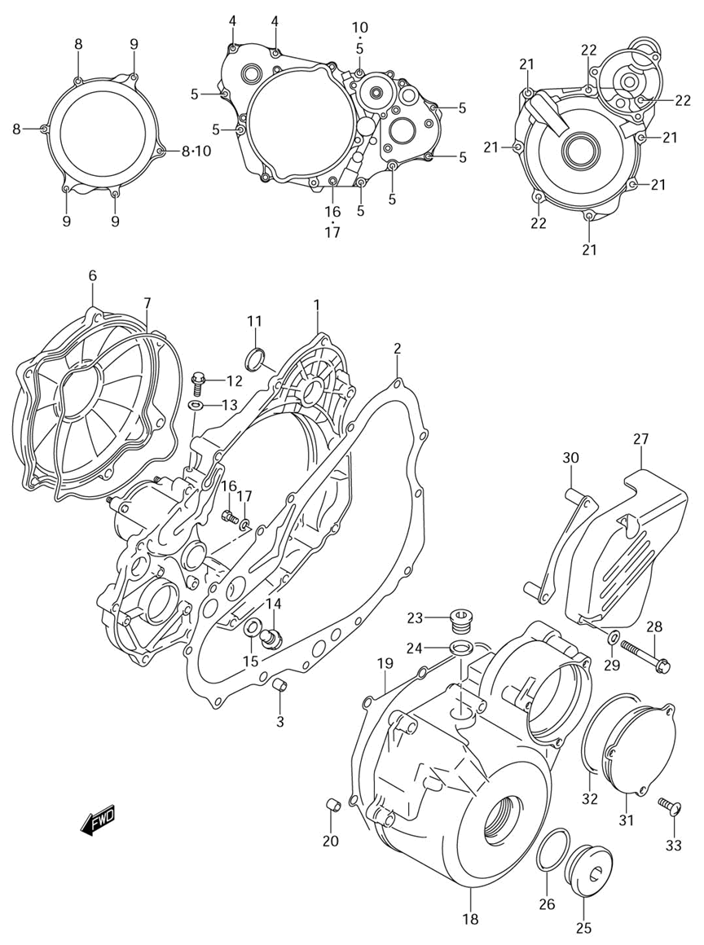

Ref | Description | Qty | SKU | Price (inc vat)
1 | Cover, Clutch Inner | 1 | 1134129F50 | € 350,76
2 | Gasket, Clutch Cover | 1 | 1148229F00 | € 25,49
3 | Pin | 2 | 0421109149 | € 1,94
4 | Bolt | 2 | 015470620A | € 2,81
5 | Bolt | 7 | 015470630A | € 2,66
6 | Cover, Clutch Outer | 1 | 1137129F50 | € 188,39
7 | O Ring, Clutch Cover Outer | 1 | 1148429F00 | € 24,58
8 | Bolt | 3 | 015470620A | € 2,81
9 | Bolt | 3 | 015470655A | € 2,70
10 | Gasket | 2 | 0916806023 | € 2,47
11 | Plug, Clutch Cover Hole | 1 | 1134215D00 | € 9,73
12 | Bolt | 1 | 015470612A | € 2,36
13 | Gasket | 1 | 0916806023 | € 2,47
14 | Plug, Main Gallery End | 1 | 0924712006 | € 3,30
15 | Gasket 12X16X2 | 1 | 0916812002 | € 2,16
16 | Bolt | 1 | 015500610A | € 1,90
17 | Gasket 6.2X11X1 | 1 | 0916806004 | € 1,77
18 | Cover, Magneto | 1 | 1135129F60 | € 305,37
19 | Gasket, Magneto Cover | 1 | 1148329F00 | € 15,65
20 | Pin | 2 | 0421109149 | € 1,94
21 | Bolt | 5 | 015470630A | € 2,66
22 | Bolt | 3 | 015470640A | € 2,89
23 | Plug | 1 | 0924814012 | € 3,38
24 | Gasket 14X19.2X | 1 | 0916814002 | € 2,84
25 | Plug | 1 | 092593601620H | € 15,81
26 | O Ring (D:3.1,Id:32.7) | 1 | 0928033004 | € 2,75
27 | Cover, Engine Sprocket | 1 | 1136029F50 | € 73,69
28 | Bolt | 2 | 015470650A | € 2,89
29 | Washer (6.5X14X2) | 2 | 0916006126 | € 2,25
30 | Plate, Front Chain Guide | 1 | 2764029F11 | € 17,16
31 | Cover, Starter Idle Gear | 1 | 1135229F50 | € 30,27
32 | O Ring (D:2.6,Id:69.6) | 1 | 0928071004 | € 25,18
33 | Screw | 3 | 021420616A | € 2,63

Crankcase
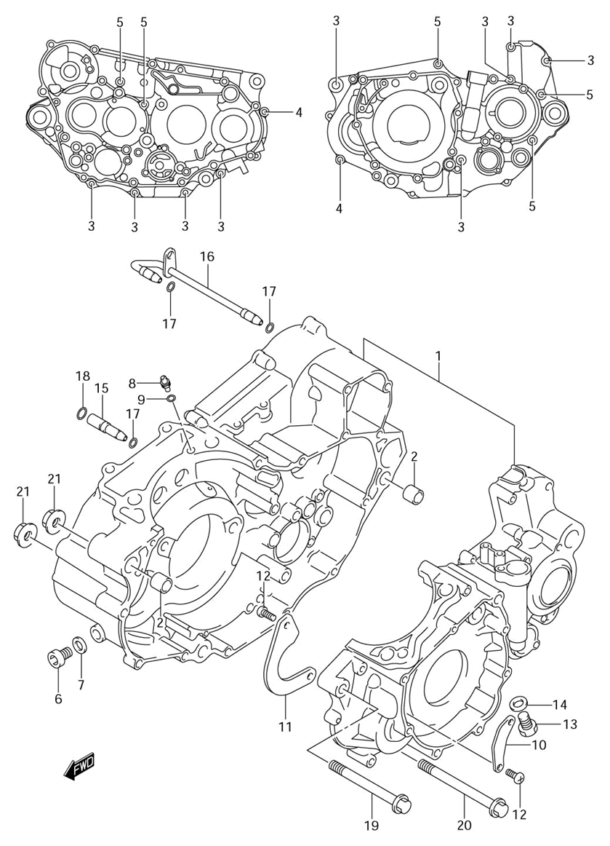

Ref | Description | Qty | SKU | Price (inc vat)
1 | Crankcase Set | 1 | 1130129851 | € 1.221,45
2 | Pin 13X18 | 2 | 0421113189 | € 2,66
3 | Bolt | 9 | 015470640A | € 2,89
4 | Bolt | 2 | 015470655A | € 2,70
5 | Bolt | 5 | 015470670A | € 3,08
6 | Plug, Oil Gallery | 1 | 0924810010 | € 5,10
7 | Gasket 10X14X3. | 1 | 0916810002 | € 2,40
8 | Jet, Oil Gallery Mission | 1 | 0949380005 | € 17,36
9 | O Ring (D:1.2,Id:4.0) | 1 | 0928004004 | € 2,05
10 | Separator, Oil No.1 | 1 | 1132329F00 | € 3,03
11 | Separator, Oil No.2 | 1 | 1132429F00 | € 4,90
12 | Screw (6X12) | 4 | 0912506110 | € 2,58
13 | Plug, Oil Drain | 1 | 0924712011 | € 5,70
14 | Gasket 12X16X2 | 1 | 0916812002 | € 2,16
15 | Pipe, Oil Inner No.1 | 1 | 1145129F00 | € 20,61
16 | Pipe, T/M Oil Inner No.2 | 1 | 1146029F00 | € 73,69
17 | O Ring | 3 | 0928005004 | € 2,16
18 | O Ring (D:1.9,Id:6.8) | 1 | 0928007004 | € 1,77
19 | Bolt (10X90) | 1 | 1860129F10 | € 11,23
20 | Bolt (10X115) | 1 | 0910310063 | € 7,72
21 | Nut | 2 | 0915910115 | € 4,29

Clutch
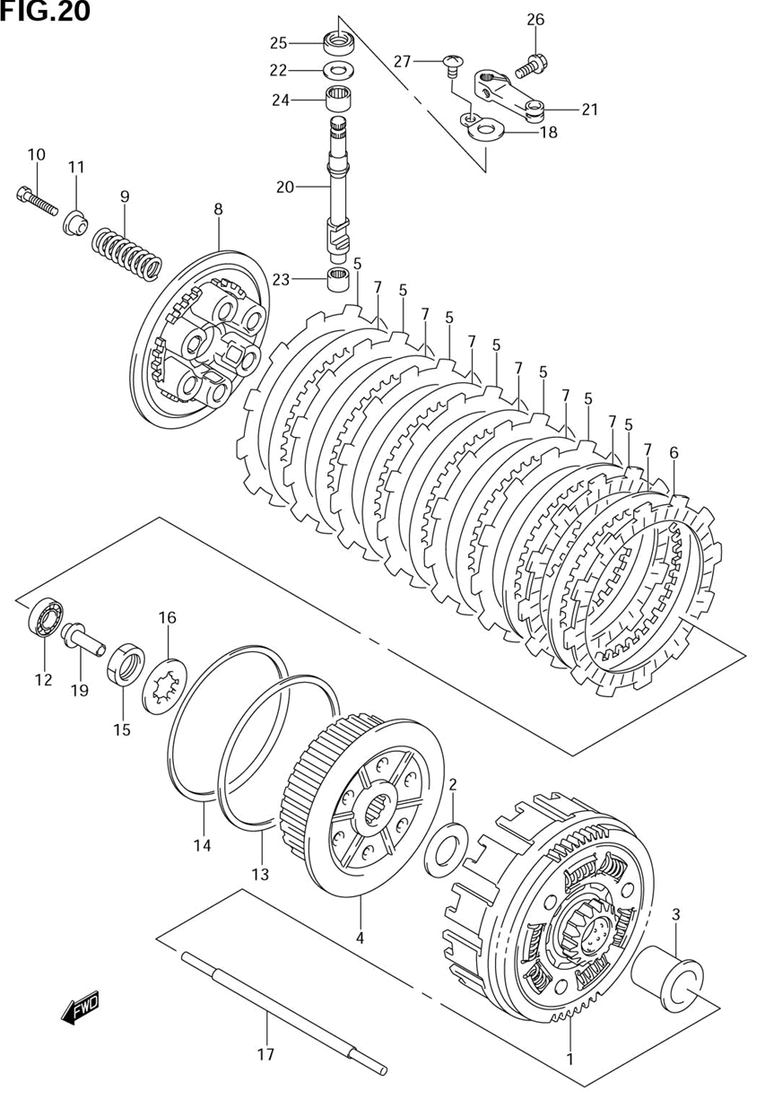

Ref | Description | Qty | SKU | Price (inc vat)
1 | Gear Assy, Primary Driven | 1 | 2120029F10 | € 432,17
2 | Washer | 1 | 0821122425 | € 5,66
3 | Spacer, Primary Driven | 1 | 2125129F00 | € 51,27
4 | Hub, Sleeve | 1 | 2141029F00 | € 142,99
5 | Plate, Drive No.1 | 7 | 2144129F00 | € 23,96
6 | Plate, Drive No.2 | 1 | 2144229F00 | € 22,93
7 | Plate, Driven | 7 | 2145144D00 | € 11,24
8 | Disc, Pressure | 1 | 2146229F00 | € 73,69
9 | Spring | 6 | 2141329F00 | € 7,85
10 | Bolt | 6 | 071300630A | € 2,97
11 | Washer | 6 | 2141429F00 | € 7,10
12 | Bearing (12X28X8) | 1 | 0926212001 | € 28,94
13 | Seat, Wave Washer | 1 | 0916000003 | € 12,64
14 | Washer, Plate | 1 | 0916400008 | € 22,89
15 | Nut | 1 | 0914020001 | € 4,18
16 | Lock Washer | 1 | 0916722021 | € 2,10
17 | Rod, Clutch Push | 1 | 2311029F00 | € 22,49
18 | Retainer, Oil Seal | 1 | 2311705200 | € 4,90
19 | Piece, Cl Rlse | 1 | 2312129F00 | € 25,06
20 | Cam Shaft, Cl Rlse | 1 | 2312229F00 | € 54,87
21 | Arm, Cl Rlse | 1 | 2327120902 | € 32,33
22 | Thrust Washer (10X20X1.0) | 1 | 0918110195 | € 2,32
23 | Bearing, Clutch Release Low | 1 | 0926310014 | € 18,39
24 | Bearing (12X16X10) | 1 | 0926312024 | € 17,16
25 | Oil Seal | 1 | 0928210012 | € 9,49
26 | Bolt | 1 | 015470616A | € 1,80
27 | Screw | 1 | 021420610A | € 2,14

Magnets
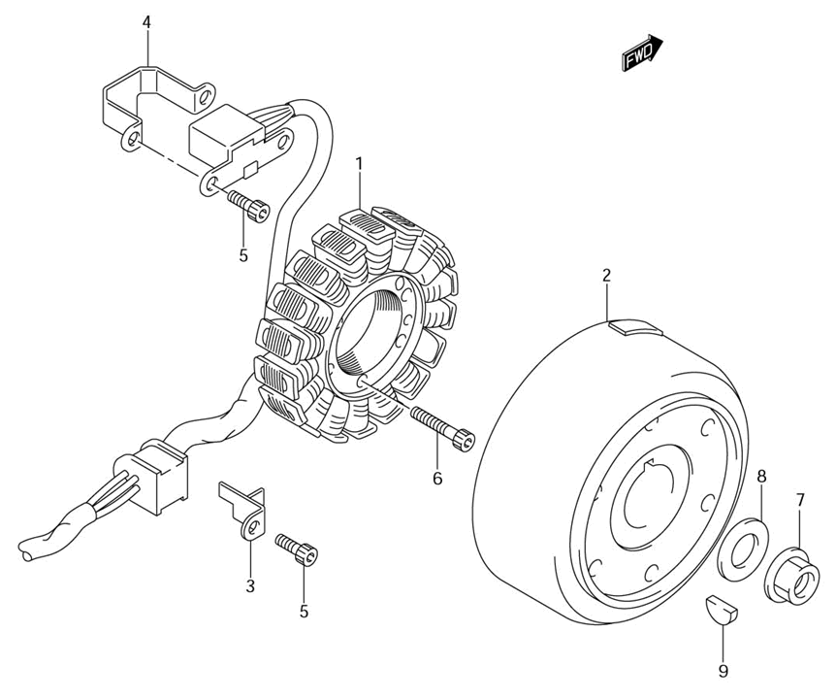
Ref | Description | Qty | SKU | Price (inc vat)
1 | Stator Assy | 1 | 3210129F00 | € 779,49
2 | Rotor Assy | 1 | 3210229F00 | € 743,36
3 | Clamp, Magneto | 1 | 3237113E00 | € 4,18
4 | Clamp, Magneto Pulser Lead | 1 | 3237114D01 | € 5,28
5 | Bolt | 3 | 071300512B | € 2,92
6 | Bolt, Stator | 3 | 071300525B | € 2,93
7 | Nut | 1 | 0915912055 | € 3,38
8 | Washer (12X27X2) | 1 | 0916012051 | € 2,25
9 | Key | 1 | 0942004008 | € 4,07

Crank balancer
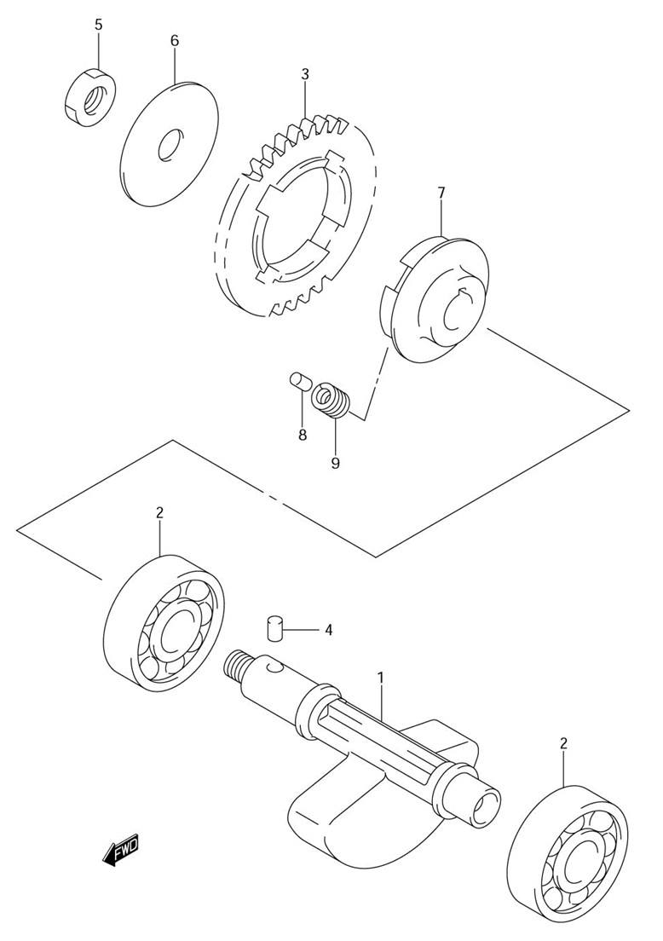

Ref | Description | Qty | SKU | Price (inc vat)
1 | Balancer, Crank | 1 | 1265129F00 | € 133,53
2 | Bearing | 2 | 0926215030 | € 28,71
3 | Gear, Driven | 1 | 1266629F11 | € 119,97
4 | Pin | 1 | 0926105005 | € 1,77
5 | Nut | 1 | 0914012039 | € 3,56
6 | Washer | 1 | 0918112009 | € 6,49
7 | Race, Driven Gear Inner | 1 | 1266929F01 | € 68,41
8 | Pin,D:4.5,L:9.5 | 2 | 0920204017 | € 4,20
9 | Spring | 4 | 0944009031 | € 3,83

Crankshaft
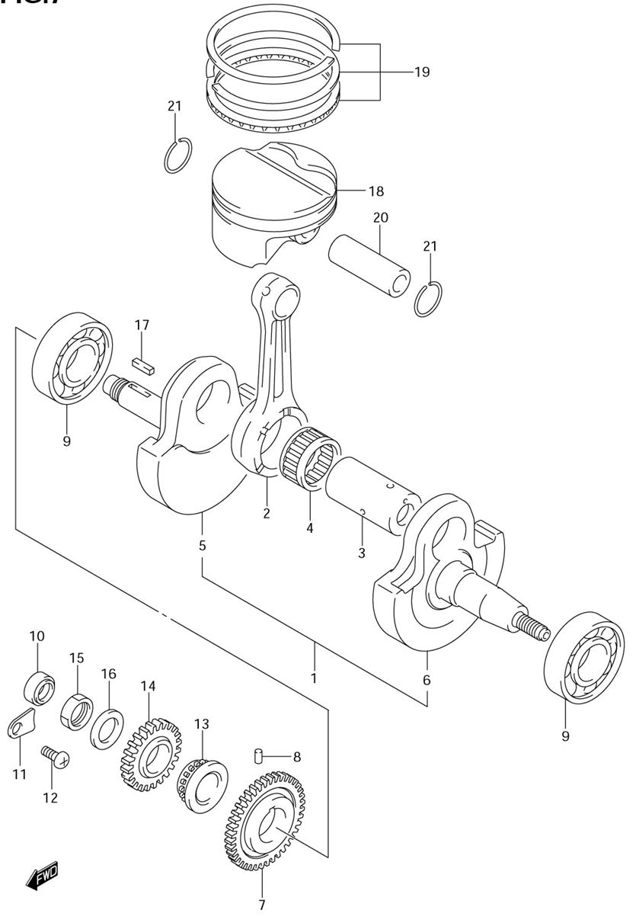

Ref | Description | Qty | SKU | Price (inc vat)
1 | Crankshaft Assy | 1 | 1220007G02 | € 744,55
2 | Rod, Connecting | 1 | 1216029F010B0 | € 157,53
3 | Pin | 1 | 1221029F10 | € 71,34
4 | Bearing | 1 | 09263350440B0 | € 85,27
5 | Crankshaft, RH | 1 | 1222107G01 | € 386,08
6 | Crankshaft, LH | 1 | 1226107G00 | € 295,53
7 | Gear, Balancer Drive | 1 | 1266129F00 | € 128,04
8 | Pin 5X8 | 1 | 0926105005 | € 1,77
9 | Bearing | 2 | 0926230100 | € 102,13
10 | Oil Seal, RH (14X 24X6) | 1 | 0928214003 | € 9,88
11 | Plate, RH | 1 | 2474218A00 | € 3,20
12 | Screw | 1 | 021120612B | € 2,06
13 | Sprocket, Cam Chain Drive | 1 | 1273129F10 | € 55,98
14 | Gear, Primary Drive | 1 | 2111129F10 | € 73,14
15 | Nut | 1 | 0914018012 | € 10,20
16 | Lock Washer | 1 | 0916418008 | € 6,19
17 | Key, Gear | 1 | 0942105002 | € 5,66
18 | Piston | 1 | 1211129F000F0 | € 156,64
19 | Ring Set, Piston | 1 | 1214029F00 | € 90,61
20 | Pin, Piston | 1 | 1215124F10 | € 24,57
21 | Circlip | 2 | 0938120004 | € 1,94

Gear shifting
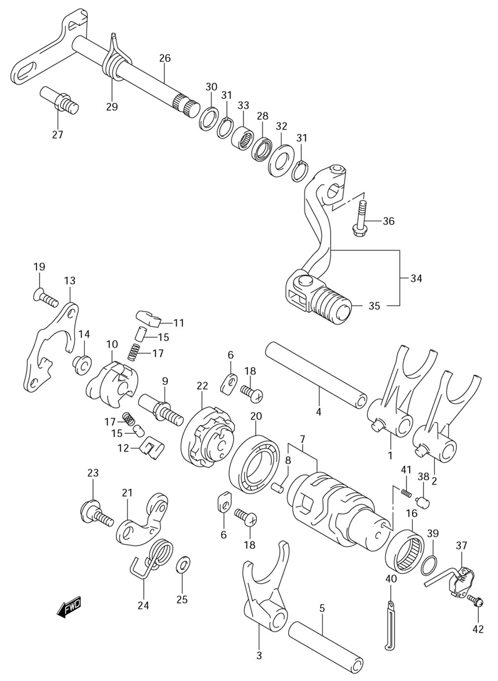

Ref | Description | Qty | SKU | Price (inc vat)
1 | Fork, Gear Shift No.1 | 1 | 2521128C01 | € 66,59
2 | Fork, No.2 | 1 | 2522128C02 | € 66,59
3 | Fork, No.3 | 1 | 2523128C02 | € 67,10
4 | Shaft, Gear Fork No.1 | 1 | 2541137F20 | € 16,97
5 | Shaft, Gear Fork, No.2 | 1 | 2542127C01 | € 14,05
6 | Retainer, Shift Cam Bearing | 2 | 2474121A00 | € 2,77
7 | Cam, Gear Shift | 1 | 2531029F10 | € 175,53
8 | Pin, Shift Cam Stopper Plate 4X8 | 1 | 0422104089 | € 1,29
9 | Pin, Shift | 1 | 2531327C02 | € 9,99
10 | Shifter, Gear Shift Cam | 1 | 2532236E00 | € 47,98
11 | Pawl, No.1 | 1 | 2532334201 | € 8,44
12 | Pawl, No.2 | 1 | 2532434201 | € 8,44
13 | Lifter, Gear Shift Pawl | 1 | 2533137E10 | € 20,09
14 | Roller | 1 | 0918007014 | € 5,13
15 | Pin | 2 | 0926105003 | € 1,77
16 | Bearing, Gear Shift | 1 | 0926325018 | € 28,98
17 | Spring | 2 | 0944004003 | € 1,75
18 | Screw (6X12) | 2 | 0912506110 | € 2,58
19 | Screw, Drive Shaft (6X12) | 2 | 0912606011 | € 2,40
20 | Bearing, RH | 1 | 0811369050 | € 48,24
21 | Stopper, Shift Cam | 1 | 2535029F00 | € 18,77
22 | Plate, Shift Cam Stopper | 1 | 2538136E11 | € 45,75
23 | Bolt, Cam Stopper Arm | 1 | 2535729F00 | € 6,58
24 | Spring, Shift Cam | 1 | 2535529F00 | € 4,67
25 | Washer | 1 | 0821106121 | € 2,25
26 | Shaft, Gear Shift | 1 | 2551029F00 | € 84,51
27 | Stopper, Arm | 1 | 2567138B00 | € 4,78
28 | Oil Seal | 1 | 0928314006 | € 7,98
29 | Spring, Shift Shaft Return | 1 | 0944420004 | € 8,75
30 | Washer | 1 | 0918114139 | € 3,04
31 | Circlip, Gear Shaft | 2 | 083313114A | € 2,21
32 | Washer, Gear Shift LH / Washer,14X29X1.?? | 1 | 0916014046XC0 | € 5,13
33 | Discontinued | 1 | 0926314027 | € 18,39
34 | Lever Assy, Gear Shift | 1 | 2560005D03 | € 77,44
35 | Rubber, Gear Shift Pedal | 1 | 2565203D00 | € 4,47
36 | Bolt, Front Brake Hose | 1 | 015470625A | € 2,36
37 | Base Assy, Gear Shift Term | 1 | 3773020F10 | € 134,22
38 | Contact | 2 | 0920905011 | € 2,25
39 | O Ring (D:2.4,Id:26.2) | 1 | 0928026005 | € 3,11
40 | Clamp | 1 | 0940406429 | € 2,06
41 | Spring | 2 | 0944004010 | € 1,75
42 | Bolt | 2 | 071200516A | € 3,04

Transmission
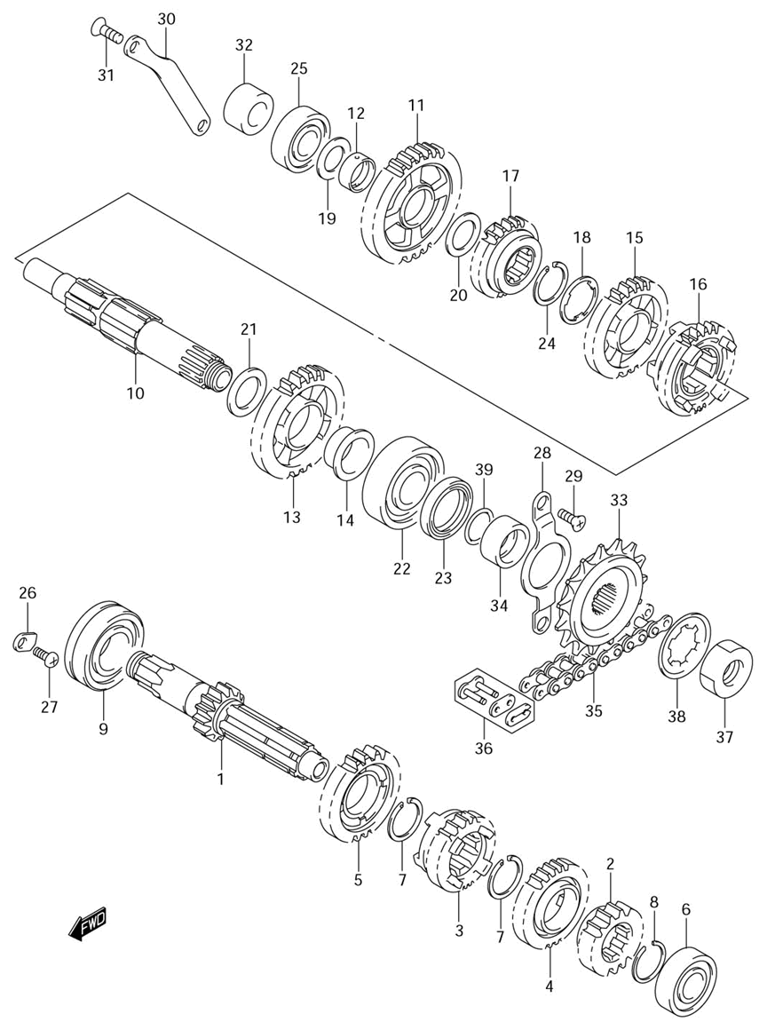

Ref | Description | Qty | SKU | Price (inc vat)
1 | Shaft, Counter (Nt:14) | 1 | 2412005D20 | € 254,74
2 | Gear, 2Nd Drive (Nt:15) | 1 | 2422128C20 | € 101,86
3 | Gear, 3Rd Drive (Nt:16) | 1 | 2423105D02 | € 121,34
4 | Gear, 4Th Drive (Nt:22) | 1 | 2424105D01 | € 101,86
5 | Gear, 5Th Drive (Nt:22) | 1 | 2425105D00 | € 101,86
6 | Bearing, LH (17X40X12) | 1 | 0926217027 | € 40,48
7 | Circlip | 2 | 0938025010 | € 3,37
8 | Circlip | 1 | 0938025013 | € 4,07
9 | Bearing (25X52X15) | 1 | 0926225003 | € 33,75
10 | Drive Shaft | 1 | 2413005D20 | € 194,31
11 | Gear, 1St Driven (Nt:32) | 1 | 2431105D00 | € 107,29
12 | Bush, 1St Driven | 1 | 2431229F00 | € 19,44
13 | Gear, 2Nd Driven (Nt:26) | 1 | 2432128C02 | € 95,94
14 | Bush, 2Nd Driven | 1 | 2432244E10 | € 32,13
15 | Gear, 3Rd Driven (Nt:22) | 1 | 2433105D01 | € 111,89
16 | Gear, 4Th Driven (Nt:24) | 1 | 2434105D01 | € 121,34
17 | Gear, 5Th Driven (Nt:19) | 1 | 2435105D20 | € 107,29
18 | Washer | 1 | 0916725012 | € 3,96
19 | Washer, 1St (17X30X1.0) | 1 | 0918117223 | € 3,56
20 | Washer (20X30X1.0) | 1 | 0918120195 | € 3,72
21 | Washer, LH (22X34X1.0) | 1 | 0918122223 | € 3,67
22 | Bearing, LH (22X56X16) | 1 | 0926222024 | € 78,23
23 | Oil Seal (30X40X6) | 1 | 0928330053 | € 10,76
24 | Circlip | 1 | 0938025010 | € 3,37
25 | Bearing (17X40X12) | 1 | 0926217023 | € 22,72
26 | Retainer, Shift Cam Bearing | 2 | 2474121A00 | € 2,77
27 | Screw (6X12) | 2 | 0912506110 | € 2,58
28 | Retainer, Drive Shaft Oil Seal | 2 | 2475129F00 | € 7,72
29 | Bolt, Retainer / Screw 6X14 | 2 | 0912606007 | € 2,40
30 | Retainer, Kick Idle | 1 | 2626429F00 | € 10,93
31 | Screw | 2 | 021220616A | € 2,14
32 | Spacer, Kick Idle 17X30.5X | 1 | 0918017055 | € 9,33
33 | Sprocket, Engine (Nt:15) | 1 | 2751029E10 | € 49,41
34 | Spacer, Engine Sprocket | 1 | 2753129F00 | € 25,35
35 | Chain Assy, Drive (Rk520Kzox112L) | 1 | 2760029F10112 | € 204,98
36 | Joint, Chain | 1 | 2762029F10 | € 16,10
37 | Nut, Engine Sprocket | 1 | 0914018006 | € 5,85
38 | Washer (22.5X40.3X0.8) | 1 | 0916722012 | € 2,00
39 | O Ring D:2.5 Id | 1 | 0928021008 | € 2,40

Water pump
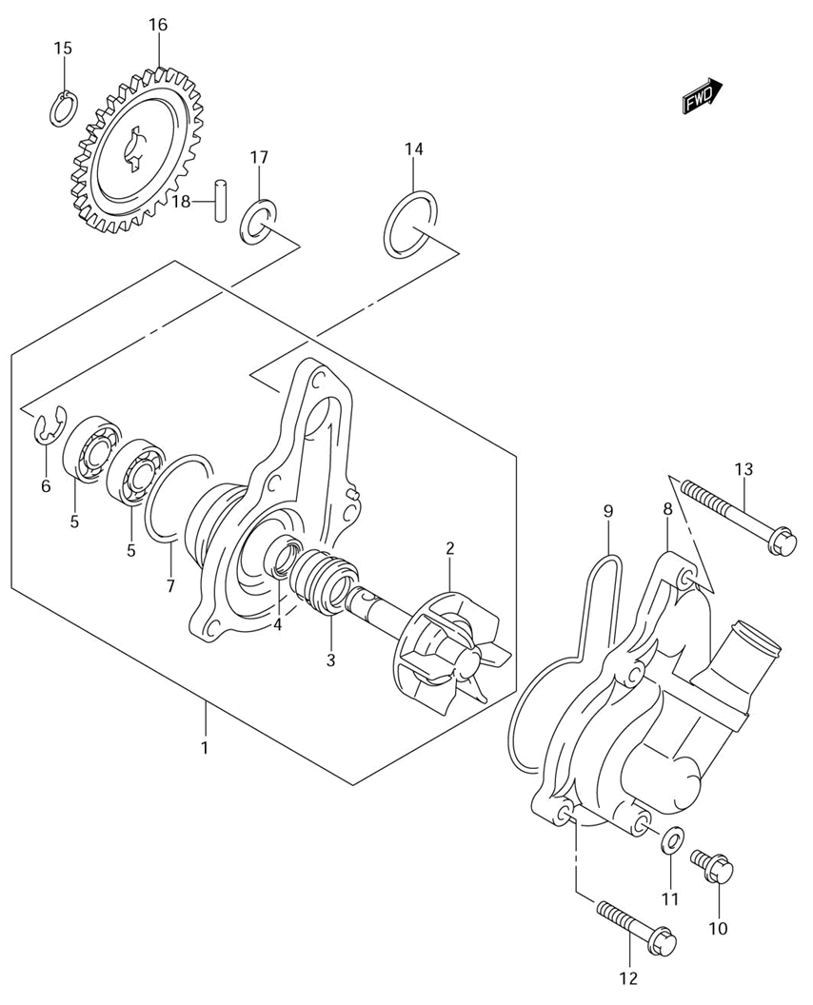

Ref | Description | Qty | SKU | Price (inc vat)
1 | Pump Assy, Water | 1 | 1740029F00 | € 236,89
2 | Impeller/Shaft | 1 | 1749129F00 | € 57,88
3 | Seal, Mechanical | 1 | 1747002F10 | € 27,20
4 | Oil Seal | 1 | 1741929F00 | € 11,74
5 | Bearing | 2 | 0811069000 | € 29,09
6 | E Ring | 1 | 083321108A | € 2,05
7 | O Ring | 1 | 1743533400 | € 17,36
8 | Case, Water Pump | 1 | 1741029F21 | € 78,55
9 | O Ring | 1 | 1743529F00 | € 11,12
10 | Bolt, Drain | 1 | 015470610B | € 3,67
11 | Gasket | 1 | 0916806026 | € 3,88
12 | Bolt | 3 | 0910306204 | € 4,03
13 | Bolt | 1 | 0910306209 | € 3,68
14 | O Ring D:2.4 Id | 1 | 0928022001 | € 1,77
15 | Circlip | 1 | 0833131106 | € 2,05
16 | Gear, Water Pump Driven | 1 | 1746129F00 | € 42,26
17 | Washer /Shim,10X18X0.5 | 1 | 0918110158 | € 2,81
18 | Pin | 1 | 0926104001 | € 1,83

Oil pump
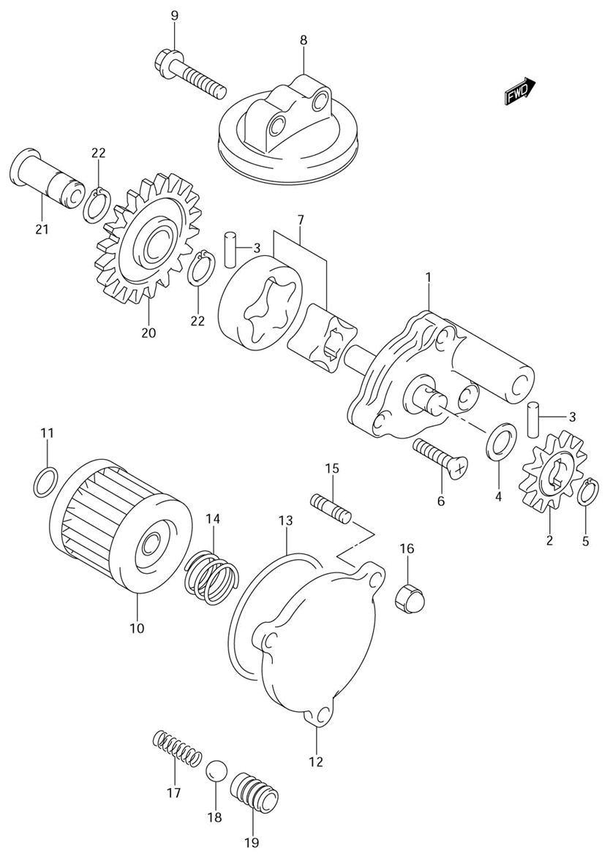

Ref | Description | Qty | SKU | Price (inc vat)
1 | Pump Assy, Engine Oil No.1 | 1 | 1640029F00 | € 203,07
2 | Gear, Driven | 1 | 1633129F01 | € 31,45
3 | Pin | 2 | 0926104009 | € 1,77
4 | Washer / Shim,10X18X0.5 | 1 | 0918110158 | € 2,81
5 | Circlip | 1 | 0833131106 | € 2,05
6 | Screw | 3 | 021220625B | € 2,16
7 | Rotor Set, Oil Pump No.2 | 1 | 1641029F00 | € 55,49
8 | Strainer, Oil Pump | 1 | 1652029F00 | € 19,14
9 | Bolt | 2 | 015500625A | € 2,42
10 | Filter, Engine Oil | 1 | 1651029F00 | € 12,96
11 | O Ring D:1.9 Id | 1 | 0928013004 | € 2,75
12 | Cap, Oil Filter | 1 | 1651247E00 | € 27,17
13 | O Ring D:2.4 Id | 1 | 0928054001 | € 4,84
14 | Spring | 1 | 0944018002 | € 1,29
15 | Bolt | 3 | 0910806123 | € 4,00
16 | Nut | 3 | 083131006A | € 2,12
17 | Spring | 1 | 0944007073 | € 5,89
18 | Ball | 1 | 0611112004 | € 2,02
19 | Seat, Oil Check Valve | 1 | 1644229F00 | € 32,71
20 | Gear, Oil Pump Idle | 1 | 1632129F00 | € 29,58
21 | Shaft | 1 | 1632229F00 | € 18,49
22 | Circlip | 2 | 0833131126 | € 2,06

Oil hose
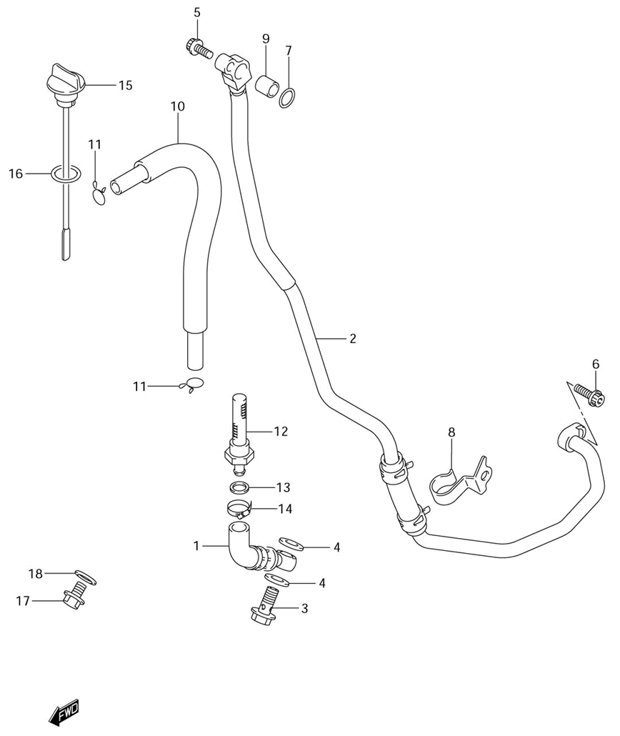

Ref | Description | Qty | SKU | Price (inc vat)
1 | Hose, Oil Tank RH | 1 | 1646029F10 | € 71,95
2 | Hose, Oil Tank LH | 1 | 1647029F20 | € 150,92
3 | Bolt,14X27 | 1 | 0936014012 | € 13,38
4 | Gasket | 2 | 0916814015 | € 1,82
5 | Bolt, Release Screw | 1 | 071200616B | € 2,77
6 | Bolt, Bracket | 1 | 071200620B | € 3,46
7 | O Ring, (D:2.4,Id:11.0) | 2 | 0928011005 | € 5,29
8 | Clamp, Oil Tank Hose | 1 | 1649129F11 | € 6,16
9 | Pin, Oil Tank Hose | 2 | 0421111129 | € 2,06
10 | Hose, Oil Over Flow | 1 | 1648029F00 | € 21,96
11 | Clip, Fuel Hose No.2 | 2 | 0940112403 | € 1,94
12 | Strainer, Frame Head Under | 1 | 1655029F00 | € 71,95
13 | Gasket | 1 | 0916818007 | € 3,19
14 | Clamp | 1 | 0940222512 | € 6,42
15 | Gauge, Oil Level | 1 | 1656129F10 | € 12,88
16 | O Ring D:3.1 Id | 1 | 0928017003 | € 2,05
17 | Plug, Oil Gallery | 1 | 0924710008 | € 3,75
18 | Gasket 10X14X3. | 1 | 0916810002 | € 2,40

Starter clutch
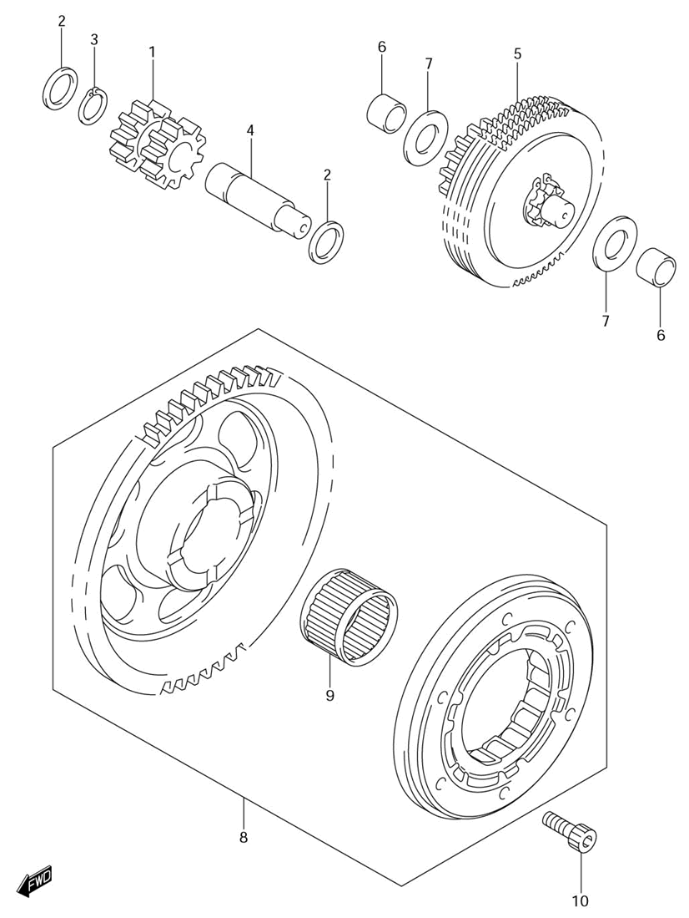

Ref | Description | Qty | SKU | Price (inc vat)
1 | Gear, Starter Idle No.1 | 1 | 1261129F00 | € 55,53
2 | Washer | 2 | 0918112130 | € 2,97
3 | Circlip | 1 | 0833131126 | € 2,06
4 | Pin | 1 | 1261529F00 | € 17,82
5 | Limiter Assy, Starter Idle Gear | 1 | 1260029F00 | € 287,28
6 | Bush, Limiter Shaft | 2 | 1261831D01 | € 24,58
7 | Washer | 2 | 0821110221 | € 2,67
8 | Clutch Set, Starter | 1 | 1260029810 | € 341,40
9 | Bearing (25X31X19) | 1 | 0926325049 | € 38,97
10 | Bolt (6X16) | 6 | 0910606073 | € 2,86

Starting motor
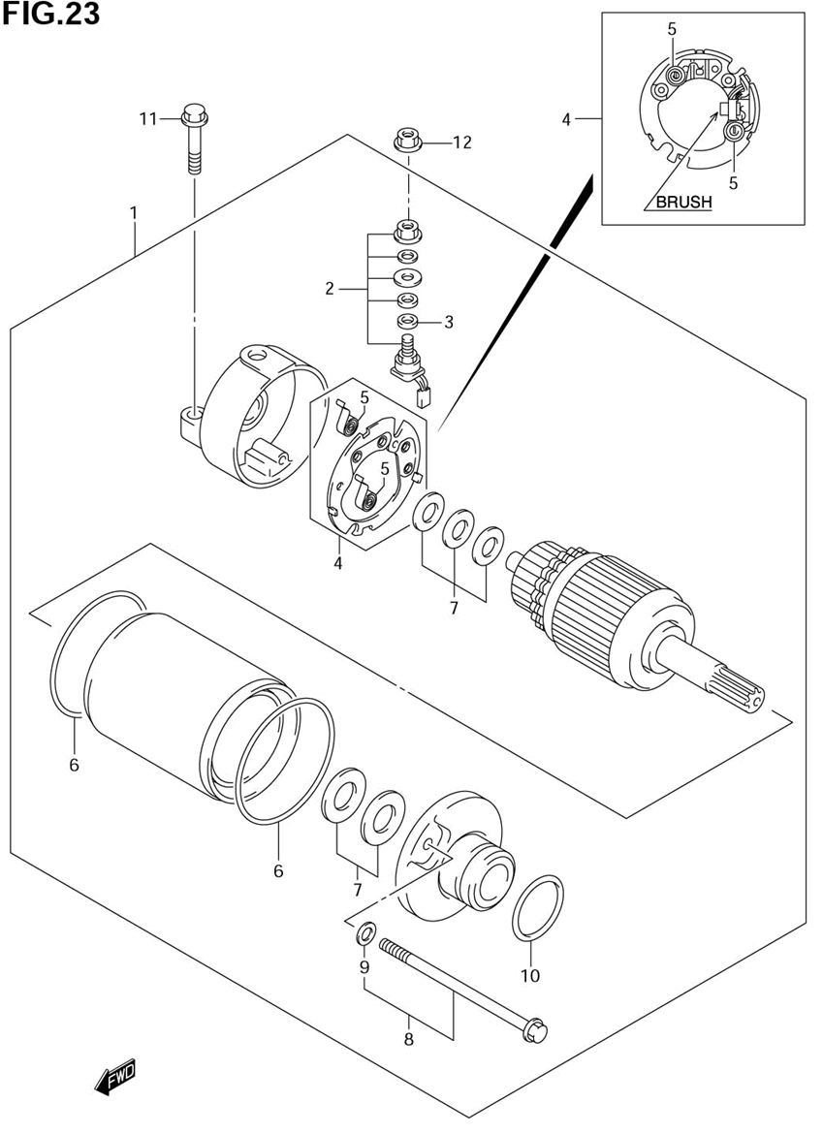

Ref | Description | Qty | SKU | Price (inc vat)
1 | Motor Assy, Starting | 1 | 3110029F00 | € 689,20
2 | Brush Terminal Set | 1 | 3113013E00 | € 58,56
3 | O Ring | 1 | 3114349040 | € 4,18
4 | Brush Holder Set | 1 | 3113213E00 | € 66,78
5 | Spring, Brush | 2 | 3113531300 | € 5,73
6 | O Ring | 2 | 3126413E00 | € 7,85
7 | Washer Set | 1 | 3117019B10 | € 12,05
8 | Set Bolt Assy | 2 | 3128019F00 | € 19,00
9 | O Ring | 2 | 3115613E00 | € 4,18
10 | O Ring D:3 Id:2 | 1 | 0928024003 | € 1,98
11 | Bolt | 2 | 0910306212 | € 2,93
12 | Nut | 1 | 083613506A | € 2,10

Electrical

Battery
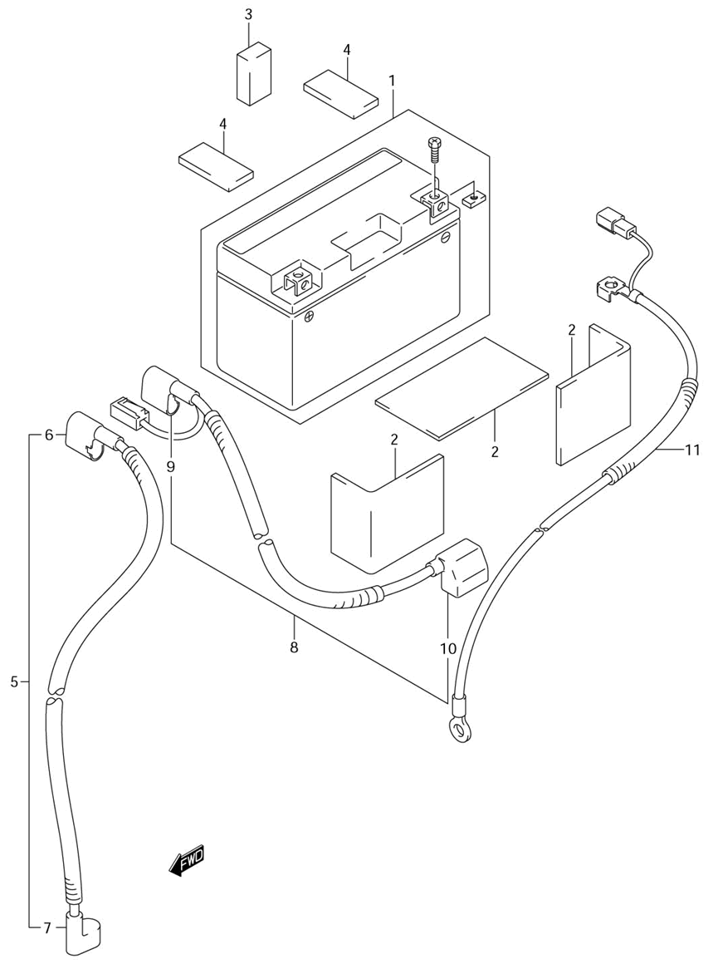

Ref | Description | Qty | SKU | Price (inc vat)
1 | Battery Assy (12V,6Ah) | 1 | 3361029F20LCP | € 169,21
2 | Protector (170X95X3.0) | 3 | 3365137000 | € 5,65
3 | Protector (70X100X6) | 1 | 3365208420 | € 5,28
4 | Cushion, Conduction Pipe | 2 | 5155315D40 | € 8,19
5 | Wire, Starter Motor Lead | 1 | 3381029F00 | € 57,46
6 | Cap, Starter Relay | 1 | 3186129F00 | € 7,10
7 | Cap, Starter Motor | 1 | 3186129F20 | € 6,62
8 | Wire, Battery Plus Lead | 1 | 3382029F00 | € 62,09
9 | Cap, Battery Plus | 1 | 3186129F10 | € 7,10
10 | Cap, Battery Plug | 1 | 3362429F00 | € 6,12
11 | Wire, Battery Minus Lead | 1 | 3386029F00 | € 46,64

Electrical
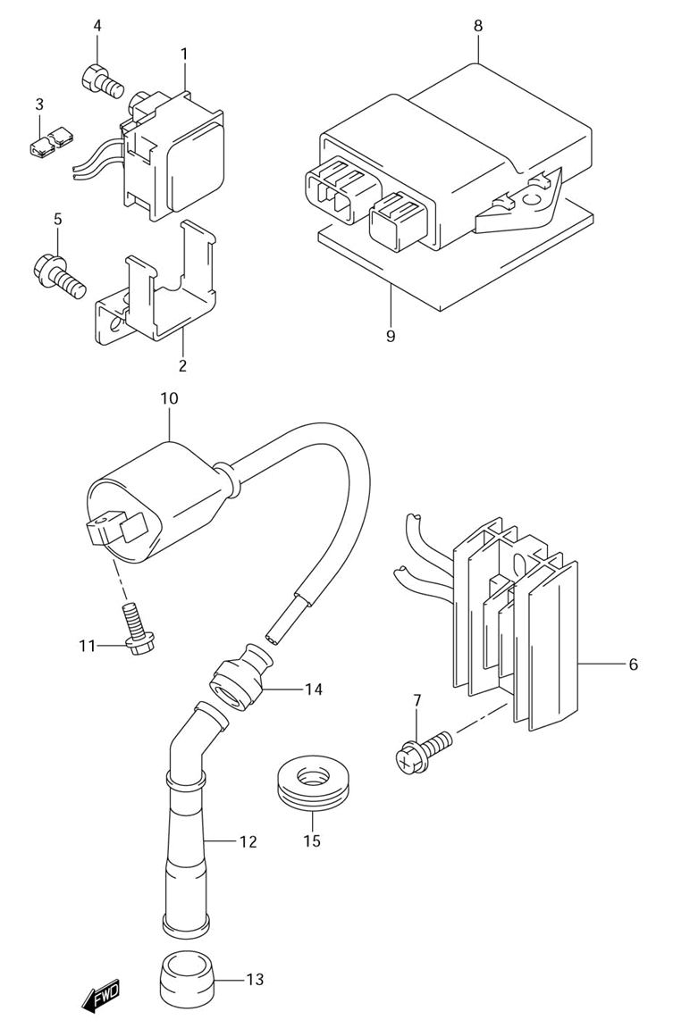

Ref | Description | Qty | SKU | Price (inc vat)
1 | Relay Assy, Starting Motor | 1 | 3180029F00 | € 114,85
2 | Bracket, Starting Motor | 1 | 3181129F00 | € 6,46
3 | Protector, Starting Motor | 1 | 3181229F00 | € 5,15
4 | Bolt | 2 | 0912806013 | € 1,60
5 | Bolt, Bracket | 1 | 015500612B | € 2,89
6 | Rectifier Assy | 1 | 3280029F00 | € 268,07
7 | Screw | 2 | 021620620B | € 1,93
8 | Cdi Unit | 1 | 3290029FA0 | € 626,34
9 | Protector (170X95X3.0) | 1 | 3365137000 | € 5,65
10 | Coil Assy, Ignition | 1 | 3341009F00 | € 112,65
11 | Bolt | 2 | 015470616B | € 2,99
12 | Cap Assy, Spark Plug | 1 | 3351048B10 | € 39,89
13 | Seal, Spark Plug Cap | 1 | 3354123E10 | € 7,48
14 | Seal, High Tension Cord | 1 | 3354238B00 | € 5,06
15 | Cover, Spark Plug Cap | 1 | 3354333E01 | € 5,28

Wiring harness
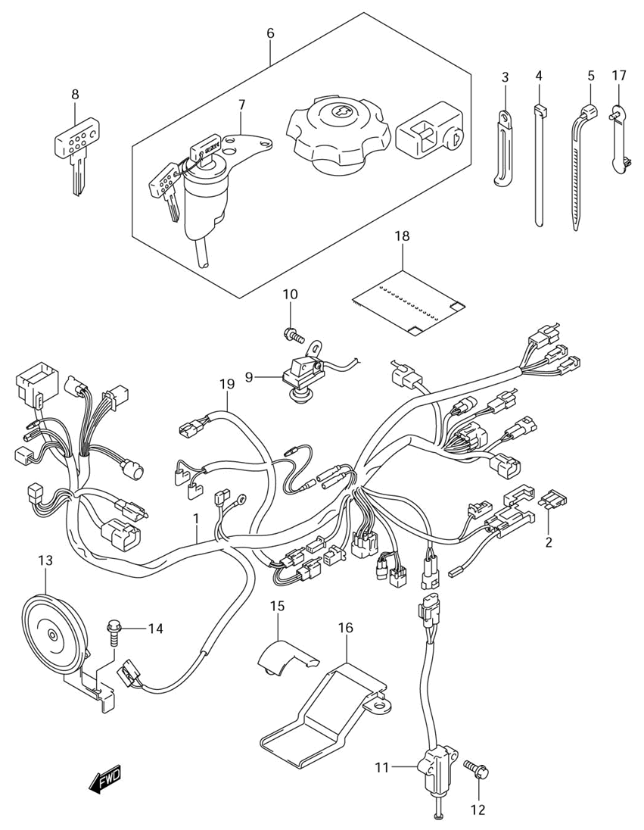

Ref | Description | Qty | SKU | Price (inc vat)
1 | Harness, Wiring | 1 | 3661029F20 | € 584,59
2 | Fuse (20A) | 2 | 0948120101A00 | € 0,45
3 | Clamp (L:80) | 1 | 0940406432 | € 2,73
3 | Clamp | 1 | 0940406429 | € 2,06
4 | Clamp | 4 | 0940714407 | € 4,44
5 | Clamp (L:235) | 5 | 0940725401 | € 5,34
5 | Clamp (L:125) | 6 | 0940714403 | € 2,80
5 | Clamp (L:165) | 4 | 0940718402 | € 2,66
6 | Lock Set | 1 | 3700029820 | € 346,65
7 | Switch Assy, Ignition | 1 | 3711029F00 | € 114,33
8 | Key, Blank (Type:C) | 1 | 3714601F00 | € 10,70
8 | Key, Blank (Type:D) | 1 | 3714601F10 | € 10,70
8 | Key, Blank (Type:E) | 1 | 3714601F20 | € 10,70
8 | Key, Blank (Type:F) | 1 | 3714601F30 | € 10,70
9 | Switch Assy, Stop Lamp | 1 | 3774029F00 | € 140,10
10 | Screw | 1 | 021620608B | € 2,32
11 | Switch Assy, Side Stand | 1 | 3784011X50 | € 112,34
12 | Bolt | 2 | 015500616B | € 2,93
13 | Horn Assy | 1 | 3850029F00 | € 79,42
14 | Bolt, Bracket | 1 | 015500612B | € 2,89
15 | Protector, Wiring Harness | 1 | 3661129F10 | € 6,62
16 | Protector, Wiring Harness | 1 | 3661129F00 | € 8,32
17 | Clamp, Wiring Harness | 1 | 3665148E00 | € 3,15
18 | Cover, Harness | 1 | 3661815D20 | € 17,37
19 | Wire, Carburetor Heater | 1 | 3685629F00 | € 38,32

Turn signal lamp
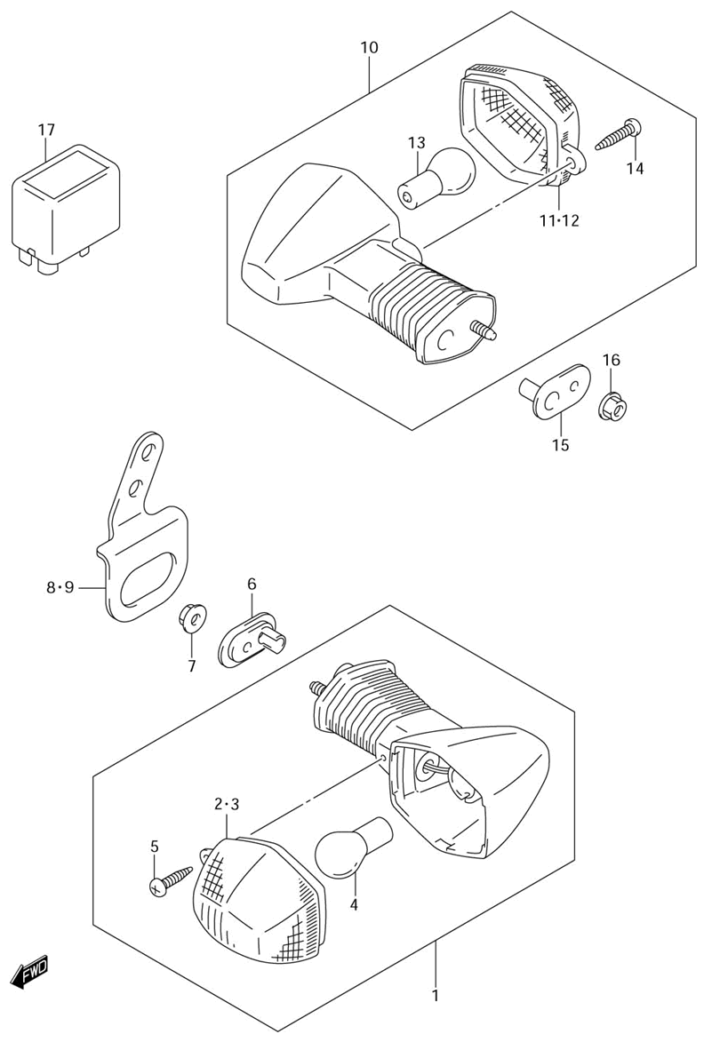

Ref | Description | Qty | SKU | Price (inc vat)
1 | Lamp Assy, Front Turn RH | 1 | 3560129F30 | € 90,03
1 | Lamp Assy, Front Turn LH | 1 | 3560229F30 | € 88,84
2 | Lens, LH | 1 | 3561231F30 | € 10,81
3 | Lens, RH | 1 | 3563231F30 | € 10,81
4 | Bulb (12V, 21W) | 2 | 0947112045 | € 6,90
5 | Screw | 2 |  | € -
6 | Plate, Rear Turn | 2 | 3562931F40 | € 5,10
7 | Nut | 2 | 083161005B | € 2,93
8 | Bracket, Front RH | 1 | 3567129F00 | € 7,41
9 | Bracket, Front LH | 1 | 3568129F00 | € 7,41
10 | Lamp Assy, Rear Turn RH | 1 | 3560329F60 | € 81,41
10 | Lamp Assy, Rear Turn LH | 1 | 3560429F60 | € 81,41
11 | Lens, RH | 1 | 3563231F30 | € 10,81
12 | Lens, LH | 1 | 3561231F30 | € 10,81
13 | Bulb (12V, 21W) | 2 | 0947112045 | € 6,90
14 | Screw | 2 |  | € -
15 | Plate, Rear Turn | 2 | 3562931F40 | € 5,10
16 | Nut | 2 | 083161005B | € 2,93
17 | Relay Assy, Turnsignal | 1 | 3861003F00 | € 131,52

Tail lamp
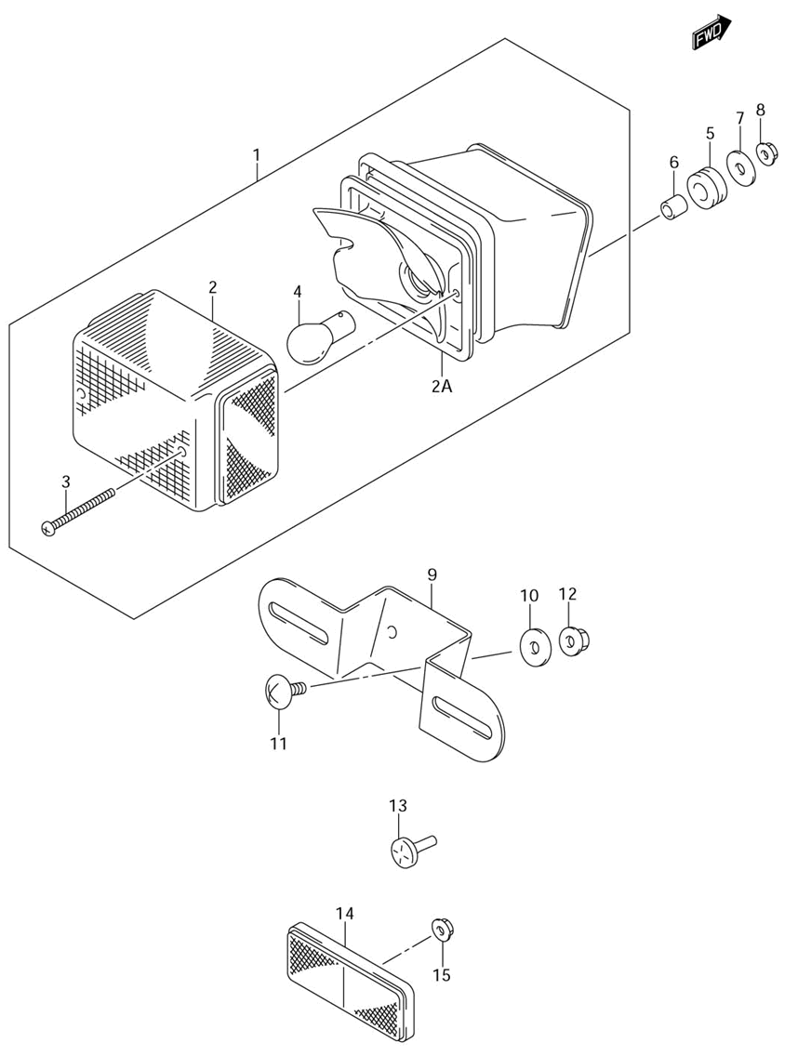

Ref | Description | Qty | SKU | Price (inc vat)
1 | Lamp Assy, Rear Combination | 1 | 3571044E20 | € 169,82
2 | Lens | 1 | 3571244E00 | € 29,48
3 | Gasket | 1 | 3571344E00 | € 5,55
4 | Discontinued | 1 | 0947112083 | € 4,57
5 | Screw 4X20 | 2 | 0321104207 | € 1,71
6 | Gasket | 2 | 3562743010 | € 2,38
7 | Washer | 2 | 0916005501 | € 2,20
8 | Cushion | 2 | 0932010501 | € 6,50
9 | Screw, Meter | 2 | 035110516B | € 2,63
10 | Cushion | 2 | 0932106026 | € 3,81
11 | Reflector Assy, Rr Side | 1 | 3597007F01 | € 27,33
12 | Nut | 1 | 083161005B | € 2,93

Headlamp
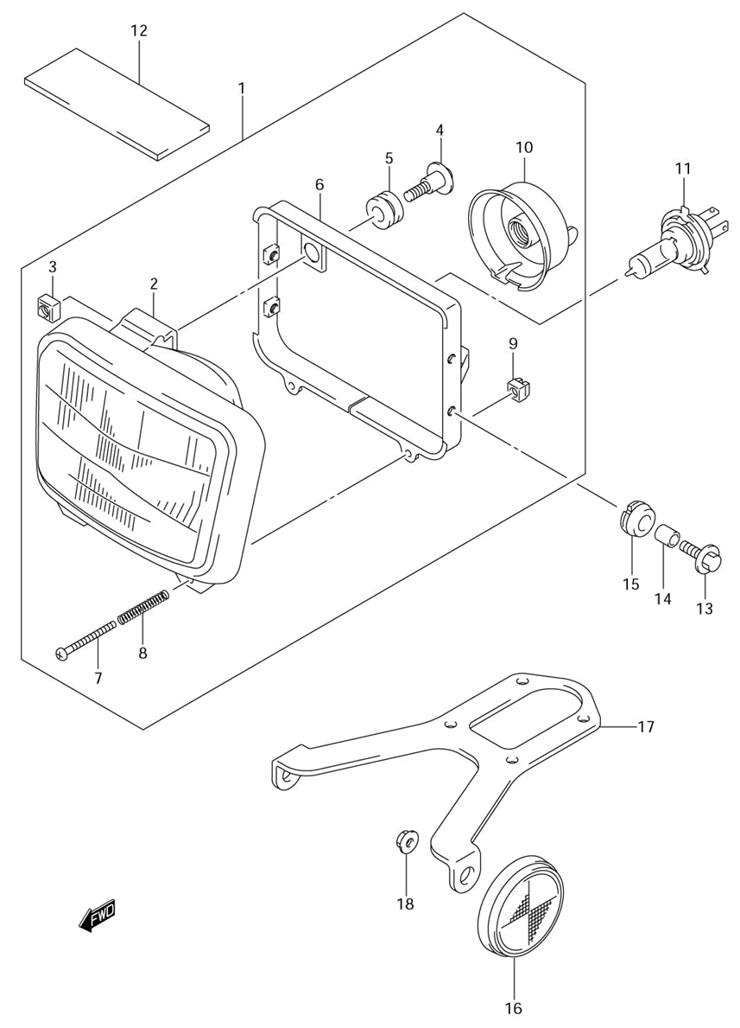

Ref | Description | Qty | SKU | Price (inc vat)
1 | Headlamp Assy | 1 | 3510012EA0999 | € 409,93
2 | Unit Assy | 1 | 3512112EA0 | € 228,45
3 | Nut | 1 | 3513545900 | € 3,15
4 | Screw, Upper | 1 | 3513638A00 | € 3,76
5 | Cushion | 1 | 3513945230 | € 1,83
6 | Housing | 1 | 3514112EA0 | € 106,24
7 | Screw, Adjusting | 2 | 3515112EA0 | € 5,84
8 | Spring, Mounting | 2 | 3515412EA0 | € 5,13
9 | Nut | 2 | 3513512E20 | € 3,60
10 | Cover | 1 | 3517301440 | € 16,19
11 | Bulb (12V,60/55W) | 1 | 0947112185 | € 17,97
12 | Protector, Wire Harness | 1 | 3692014D00 | € 7,15
13 | Bolt | 4 | 0911606167 | € 2,52
14 | Spacer (6.5X10X10) | 4 | 0918006310 | € 2,42
15 | Cushion | 4 | 0932009018 | € 2,46
16 | Rerlex Reflector Assy | 2 | 3595014A10 | € 15,92
17 | Bracket, Fr Side | 1 | 3595629F00 | € 12,00
18 | Nut | 2 | 083161005B | € 2,93

Fuel

Air cleaner
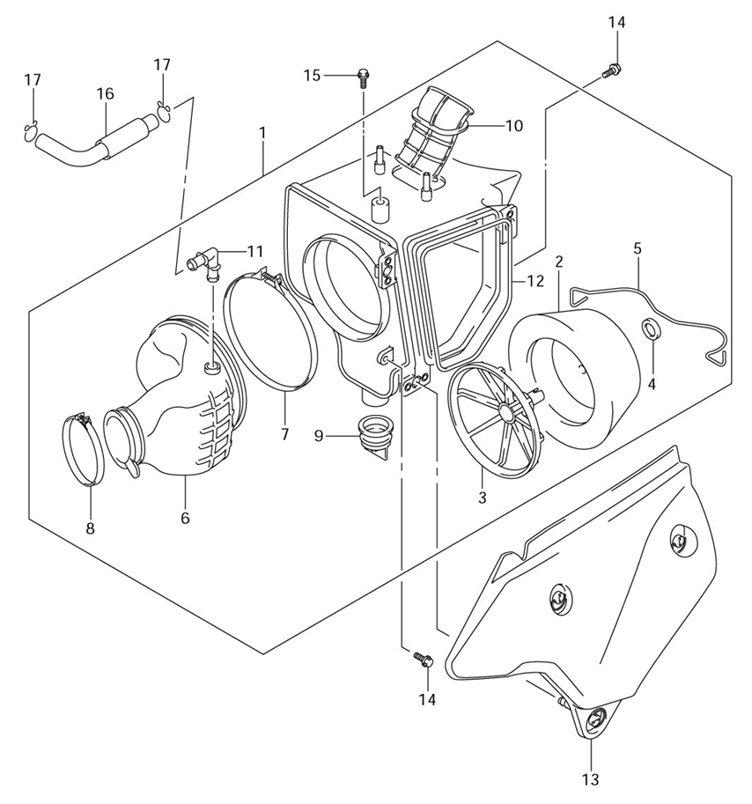

Ref | Description | Qty | SKU | Price (inc vat)
1 | Cleaner, Air | 1 | 1370129FA1 | € 633,14
2 | Filter, Air Cleaner | 1 | 1378044E00 | € 82,23
3 | Holder, Filter | 1 | 1379144E00 | € 17,71
4 | Spacer | 1 | 1379644E00 | € 4,25
5 | Spring | 1 | 1394129F00 | € 38,71
6 | Tube, Outlet | 1 | 1388129FA0 | € 94,61
7 | Joint | 1 | 0936708001 | € 3,99
8 | Clamp | 1 | 1382629F00 | € 9,41
9 | Clamp | 1 | 0940264203 | € 8,05
10 | Valve | 1 | 1387229F00 | € 11,99
11 | Tube, Inlet | 1 | 1389129FA0 | € 36,45
12 | Joint, Breather Hose | 1 | 1385814D20 | € 8,44
13 | Gasket, Air Cleaner | 1 | 1374629F00 | € 6,57
14 | Cap, Air Cleaner (White) | 1 | 1374029FA130H | € 185,31
15 | Bolt | 2 | 015470616B | € 2,99
16 | Bolt | 1 | 0911106054 | € 1,98
17 | Tube, Breather | 1 | 1385029FA1 | € 13,91
18 | Clip | 2 | 0940114101 | € 2,58
19 | Hose, Solenoid Valve | 1 | 1369729FA0 | € 11,20

Carburetor
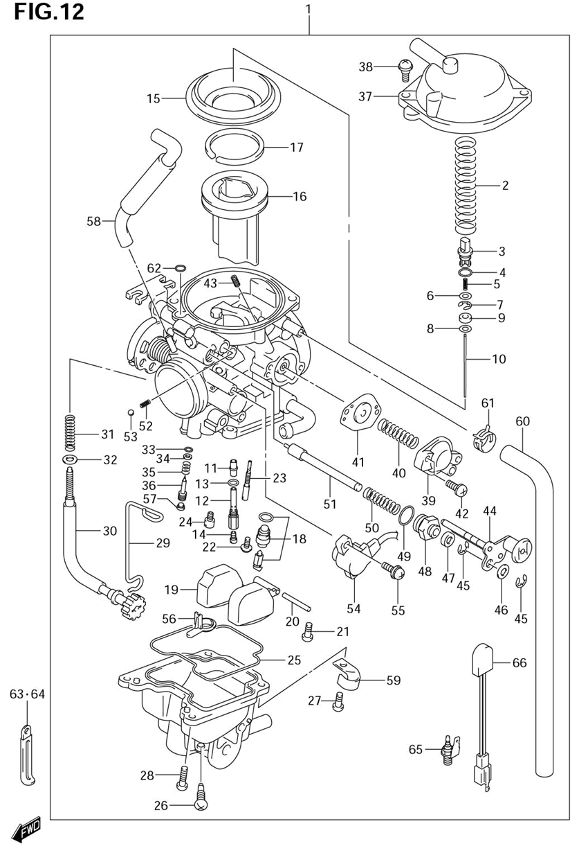
Ref | Description | Qty | SKU | Price (inc vat)
1 | Carburetor Assy | 1 | 1320029FA1 | € 834,69
2 | Spring | 1 | 1357307F00 | € 13,07
3 | Holder | 1 | 1341833E00 | € 6,69
4 | O Ring | 1 | 0928005004 | € 2,16
5 | Spring | 1 | 1348104F00 | € 3,20
6 | Washer | 1 | 1338219E00 | € 4,18
7 | E Ring | 1 | 1339417E60 | € 1,93
8 | Ring | 1 | 1338713F00 | € 8,85
9 | Washer | 1 | 1329129FA0 | € 3,47
10 | Needle, Jet (5Dh36-2) | 1 | 1338329FA0 | € 19,00
11 | Jet, Needle (P-0M) | 1 | 0949400939 | € 40,67
12 | Holder, Jet | 1 | 1338529FA0 | € 32,71
13 | O Ring | 1 | 1324643010 | € 4,84
14 | Jet, Main (142.5) | 1 | 1334729FA0 | € 16,62
15 | Diaphragm | 1 | 1350717C01 | € 34,25
16 | Valve, Piston | 1 | 1350129FA0 | € 85,93
17 | Ring | 1 | 1350414E00 | € 6,00
18 | Valve Assy, Needle | 1 | 1337029FA0 | € 72,47
19 | Float Assy | 1 | 1325004F00 | € 41,17
20 | Pin | 1 | 1325401010 | € 4,21
21 | Screw | 1 | 0211204083 | € 1,97
22 | Screw | 1 | 1360205A10 | € 4,26
23 | Jet, Pilot (22.5) | 1 | 0949222014 | € 16,62
24 | Jet, Main Air (62.5) | 1 | 0949162006 | € 8,92
25 | Gasket | 1 | 1325804F00 | € 11,48
26 | Screw, Drain | 1 | 1324702340 | € 6,19
27 | Screw | 3 | 0211204107 | € 1,97
28 | Discontinued | 1 | 0211204123 | € 1,56
29 | Clip | 1 | 1367129FA0 | € 17,77
30 | Adjust Screw Assy | 1 | 1326729FA0 | € 60,29
31 | Spring | 1 | 1326837420 | € 5,16
32 | Washer | 1 | 1361543010 | € 3,15
33 | O Ring | 1 | 1329529900 | € 4,52
34 | Washer | 1 | 1329129900 | € 2,09
35 | Spring | 1 | 1326848700 | € 4,95
36 | Screw, Pilot (3,3/8) | 1 | 1327933E00 | € 12,32
37 | Cover Assy, Diaphragm | 1 | 1350229FA0 | € 47,73
38 | Screw | 2 | 1324733E00 | € 3,25
39 | Cover Assy | 1 | 1350210F00 | € 38,71
40 | Spring | 1 | 1348141F20 | € 4,51
41 | Diaphragm Assy | 1 | 1348010F00 | € 21,65
42 | Screw | 1 | 1360104148 | € 3,15
43 | Jet, Pilot Air (165) | 1 | 0949333002 | € 15,65
44 | Plate Assy | 1 | 1342029FA0 | € 67,49
45 | E Ring | 2 | 1341538300 | € 1,93
46 | Washer | 1 | 1342738300 | € 1,74
47 | Cap, Starter | 1 | 1368231210 | € 5,34
48 | Holder | 1 | 1341844080 | € 11,47
49 | O Ring | 1 | 1327847090 | € 2,16
50 | Spring | 1 | 1341743010 | € 5,16
51 | Plunger Assy | 1 | 1341129FA0 | € 28,67
52 | Spring | 1 | 1343443010 | € 6,38
53 | Steel Ball | 1 | 1359693010 | € 4,83
54 | Sensor Assy | 1 | 1358021F00 | € 127,51
55 | Screw | 2 | 1360219B50 | € 4,07
56 | Ring | 1 | 1338729FA1 | € 12,87
57 | Solenoid | 1 | 1353029FA0 | € 209,26
58 | O Ring | 1 | 1352129FA0 | € 3,54
59 | Rubber Seat | 1 | 1327829FA0 | € 6,77
60 | O Ring | 1 | 1327839C10 | € 6,12
61 | Nipple | 1 | 1368529FA0 | € 29,55
62 | Screw | 1 | 0211205127 | € 2,42
63 | Plate | 1 | 1367114D00 | € 4,17
64 | Hose (7X11) | 1 | 1368429FA0 | € 28,68
65 | Spring | 1 | 1348129FA0 | € 14,67
66 | Hose, Air Vent (6.5X10.5) | 1 | 1368429FB0 | € 32,41
67 | Clip | 1 | 1367111300 | € 6,38
68 | Hose, Overflow (4.5X8X400) | 1 | 1368347030 | € 12,46
69 | O Ring | 1 | 1329533010 | € 5,50
70 | Clamp | 1 | 0940406429 | € 2,06
71 | Clamp,L:137 | 1 | 0940408420 | € 4,57
76 | Heater Assy, Carburetor | 1 | 1365025E01 | € 47,06
77 | Thermo Switch, Carb Heater | 1 | 1365516F00 | € 61,77

Fuel cock
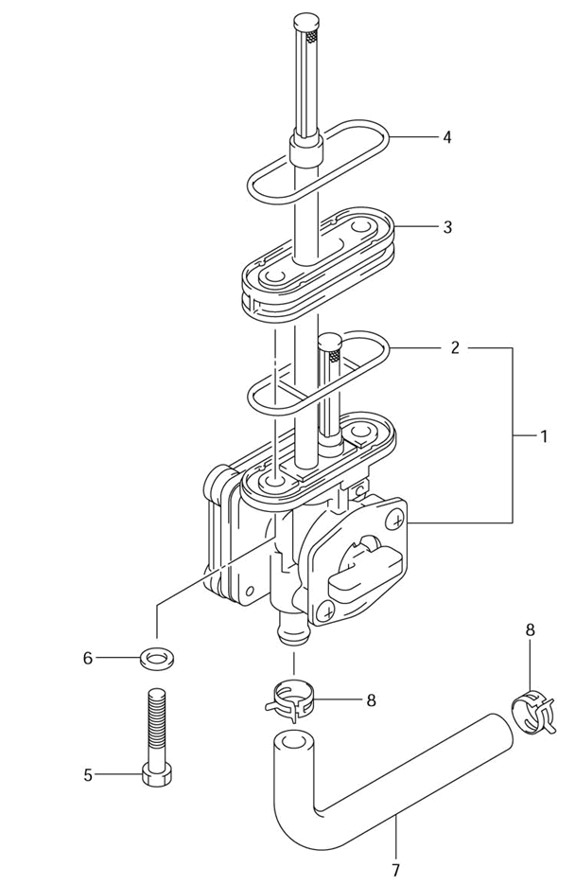
Ref | Description | Qty | SKU | Price (inc vat)
1 | Cock Assy, Fuel | 1 | 4430029F00 | € 130,65
2 | Gasket | 1 | 4434887420 | € 6,99
3 | Spacer | 1 | 4436529F00 | € 35,36
4 | Gasket | 1 | 4436614A00 | € 3,56
5 | Bolt | 2 | 0912806010 | € 1,86
6 | Gasket | 2 | 0916806026 | € 3,88
7 | Hose, Fuel | 1 | 4442129F20 | € 11,51
8 | Clip | 2 | 0940111415 | € 2,80

Fuel tank
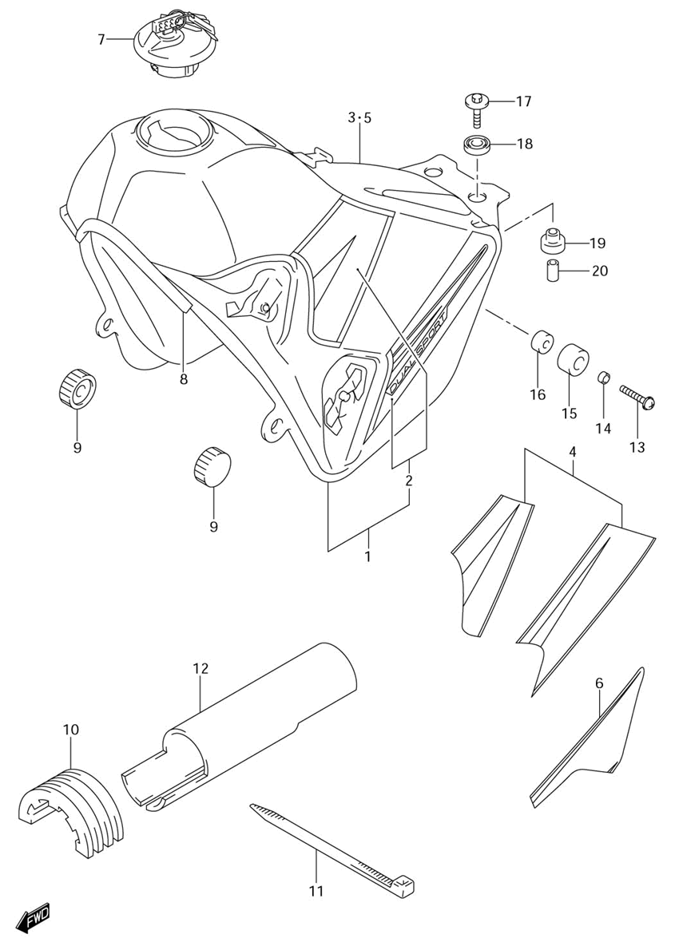

Ref | Description | Qty | SKU | Price (inc vat)
1 | Tank Assy, Fuel (Blue) | 1 | 4410029FJ0YC2 | € 845,36
1 | Tank Assy, Fuel (Yellow) | 1 | 4410029FJ0YU1 | € 797,40
2 | Tape Set | 1 | 6811029FB0BEV | € 105,86
2 | Tape Set | 1 | 6811029FB0AZR | € 100,68
9 | Cap Set, Fuel Tank | 1 | 4420029820 | € 179,39
10 | Mold, Fuel Tank | 1 | 6824104X5000B | € 26,08
11 | Cushion, Front | 2 | 0932910016 | € 3,91
12 | Cushion, Upper | 1 | 4454129F00 | € 31,82
13 | Clamp | 2 | 0940730402 | € 5,10
14 | Shield, Fuel Tank | 1 | 4419429F00 | € 57,46
19 | Bolt, Rear | 2 | 0911606172 | € 2,92
20 | Cushion, Upper | 2 | 0932014022 | € 5,12
21 | Cushion, Rear (9X24X18) | 2 | 0932010020 | € 4,47
22 | Spacer 6,5X9X18 | 2 | 0918006271 | € 2,52

Pair system
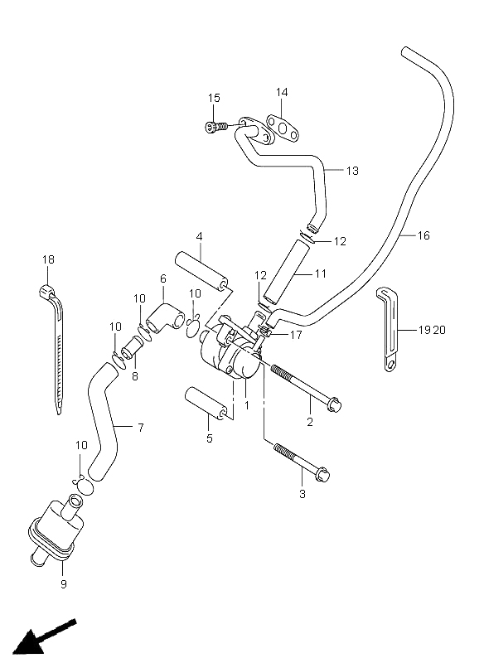

Ref | Description | Qty | SKU | Price (inc vat)
1 | Valve Assy, 2Nd Air | 1 | 1845029F01 | € 172,57
2 | Bolt, Front | 1 | 015500675B | € 3,73
3 | Bolt | 1 | 015500660B | € 3,73
4 | Spacer, Valve Front | 1 | 1861129F00 | € 12,49
5 | Spacer, Valve Rear | 1 | 1861229F00 | € 11,20
6 | Hose, Cleaner Joint | 1 | 1871229F00 | € 5,50
7 | Hose, Cleaner | 1 | 1871129F00 | € 8,50
8 | Joint, 2Nd Air Cleaner Hose | 1 | 1388819B00 | € 7,85
9 | Cleaner, 2Nd Air | 1 | 1870029F00 | € 18,03
10 | Clip | 4 | 0940115101 | € 2,20
11 | Hose, 2Nd Air Valve | 1 | 1846129F00 | € 25,37
12 | Clip | 2 | 0940113409 | € 2,97
13 | Pipe, 2Nd Air | 1 | 1841029F10 | € 50,90
14 | Gasket | 1 | 1844145C01 | € 6,57
15 | Bolt | 2 | 071300616B | € 3,30
16 | Hose | 1 | 0935540805600 | € 10,81
17 | Clip | 1 | 0940108409 | € 2,32
18 | Clamp,L:165 | 1 | 0940718402 | € 2,66
19 | Clamp | 1 | 0940406429 | € 2,06
20 | Clamp(L:45 T:0.6) | 1 | 0940408205 | € 3,67

Frame

Frame
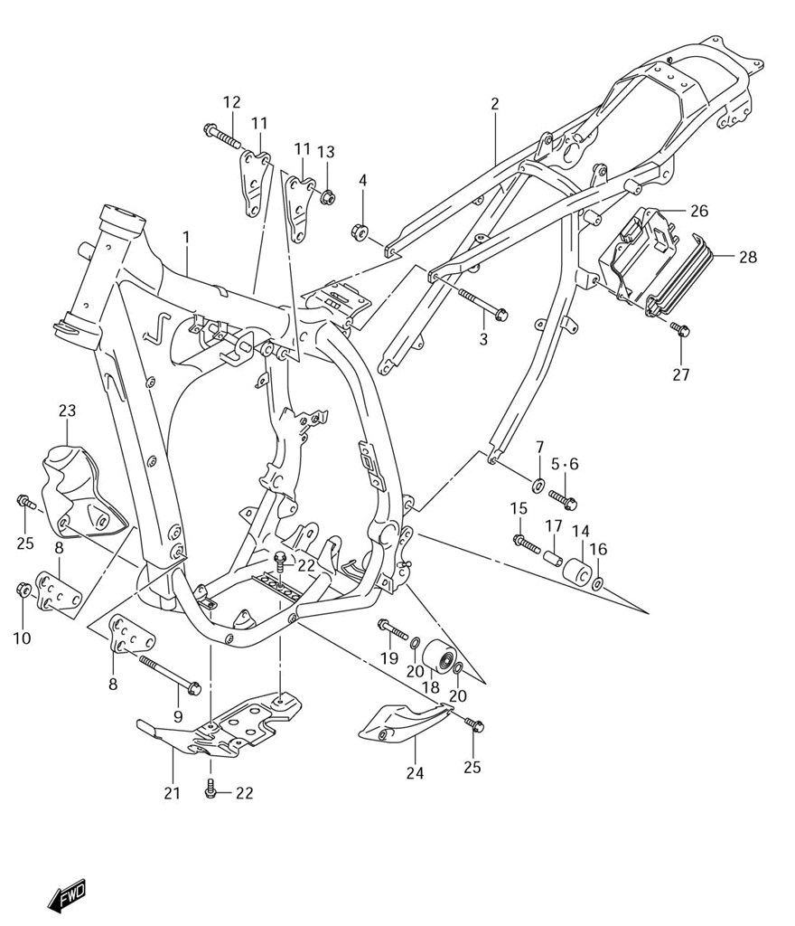

Ref | Description | Qty | SKU | Price (inc vat)
1 | Frame (Gray) | 1 | 4110029F32YU8 | € 2.237,69
2 | Rail, Seat | 1 | 4120029F50 | € 1.600,88
3 | Bolt 8X115 | 1 | 0910308098 | € 4,28
4 | Nut | 1 | 083193108A | € 2,93
5 | Bolt, LH (8X16) | 1 | 0910408035 | € 3,03
6 | Bolt | 1 | 0910308341 | € 4,78
7 | Washer (8.5X18X2.0) | 2 | 0916008120 | € 3,23
8 | Plate, Engine Mount Front RH | 1 | 4191129F00 | € 38,32
9 | Plate, Engine Mount Front LH | 1 | 4191129F10 | € 17,37
10 | Bolt | 2 | 0910308363 | € 9,23
11 | Nut | 2 | 083193108A | € 2,93
12 | Plate, Engine Mount Rear | 2 | 4199329F10 | € 30,20
13 | Bolt | 2 | 0910308081 | € 4,81
14 | Nut | 2 | 083193108A | € 2,93
15 | Roller, Chain | 1 | 4391113E00 | € 19,53
16 | Bolt, Upper | 1 | 0910308083 | € 4,55
17 | Washer | 1 | 0821108201 | € 2,72
18 | Spacer | 1 | 0918008215 | € 5,02
19 | Roller, Chain Control | 1 | 4391027C11 | € 57,02
20 | Bolt, Upper | 1 | 0910308083 | € 4,55
21 | Washer | 2 | 0918108111 | € 2,25
22 | Protector, Engine | 1 | 4251029F00 | € 130,68
23 | Bolt, Bracket | 4 | 015500612B | € 2,89
24 | Guard, Water Pump | 1 | 4252129F001KY | € 17,24
25 | Guard, Mag Cover | 1 | 4253129F00 | € 31,79
26 | Bolt,8X16.5 | 4 | 0911108096 | € 3,47
27 | Holder, Battery | 1 | 4154129F00 | € 60,70
28 | Bolt | 3 | 0911106072 | € 2,47
29 | Band | 1 | 4156129F00 | € 22,91

Frame cover
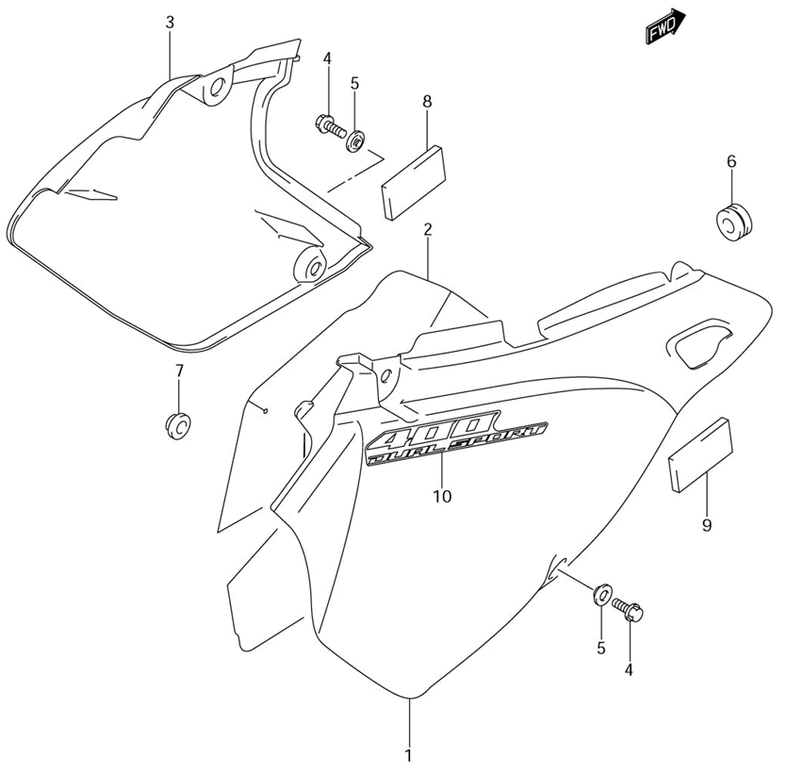
Ref | Description | Qty | SKU | Price (inc vat)
1 | Cover, Frame RH (White) | 1 | 4711129F2030H | € 80,25
2 | Shield, Frame Cover RH | 1 | 4716629F00 | € 65,26
3 | Cover, Frame LH (White) | 1 | 4721129F1030H | € 56,88
4 | Bolt | 2 | 0154706163 | € 2,99
5 | Washer | 2 | 0916906041 | € 3,07
6 | Grommet, Cover | 1 | 0932006504 | € 4,87
7 | Cushion, Muffler Rear | 1 | 0932110018 | € 5,65
8 | Cushion, LH Cover Front | 1 | 4716129F00 | € 5,37
9 | Cushion, RH Cover Front | 1 | 7176265G10 | € 8,05

Seat
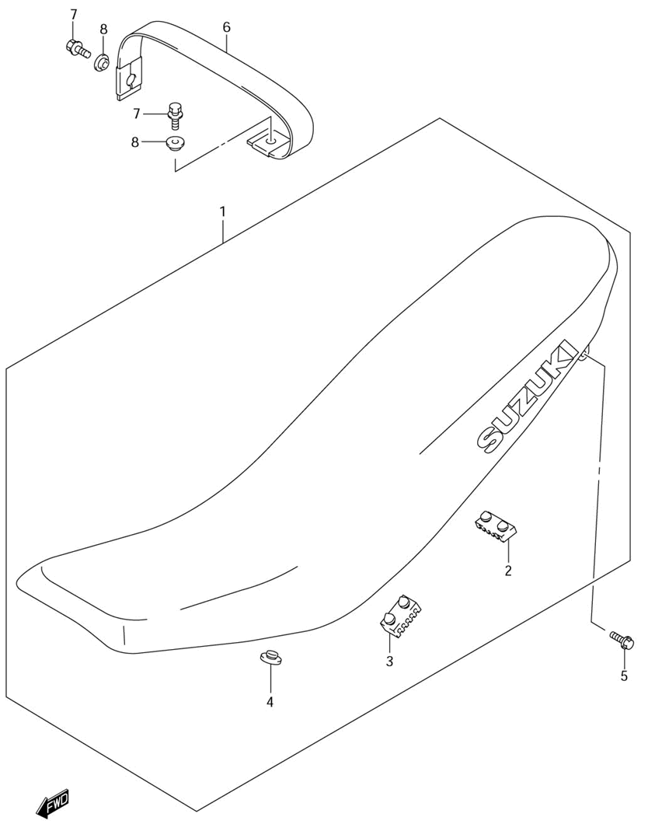
Ref | Description | Qty | SKU | Price (inc vat)
1 | Seat Assy | 1 | 4510029FB0BAE | € 530,48
1 | Seat Assy | 1 | 4510029FB0BDL | € 499,25
2 | Cushion, Front | 2 | 4514912C00 | € 6,45
3 | Cushion | 4 | 4514931300 | € 4,18
4 | Cushion, Front | 2 | 0932110022 | € 2,51
5 | Bolt, Oil Strainer Cap | 2 | 015500620A | € 2,42
6 | Band Assy, Seat | 1 | 4518029F00P21 | € 56,13
7 | Bolt (6X25) | 2 | 0911606150 | € 2,92
8 | Washer (6.3X17X6) | 2 | 0916906063 | € 4,00

Stand
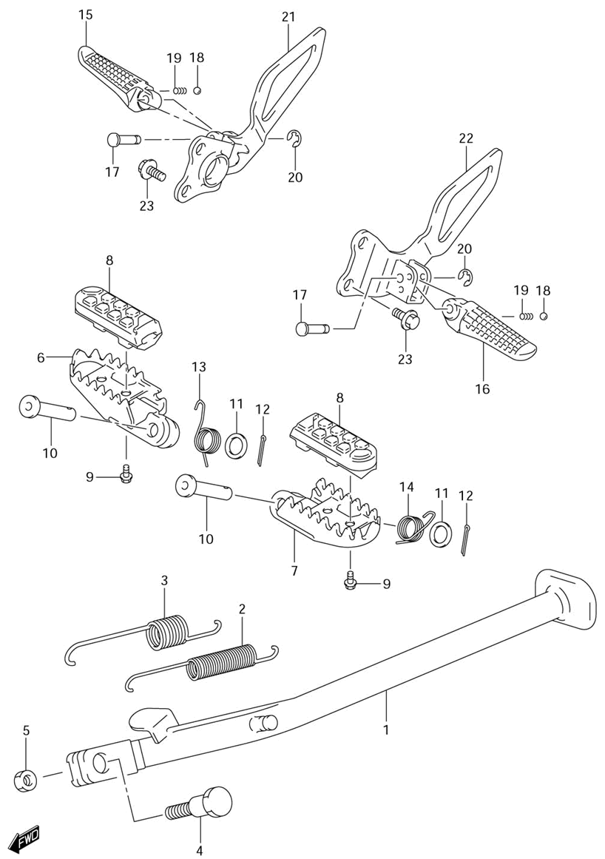

Ref | Description | Qty | SKU | Price (inc vat)
1 | Stand, Propeller | 1 | 4231044E00 | € 137,91
2 | Spring, No.1 | 1 | 0944312036 | € 9,61
3 | Spring, No.2 | 1 | 0944319010 | € 7,99
4 | Bolt | 1 | 0911110060 | € 4,76
5 | Nut, Prop Stand | 1 | 4232103FK0 | € 6,12
6 | Footrest, RH | 1 | 4355029E01 | € 75,63
7 | Footrest, LH | 1 | 4356029E01 | € 75,63
8 | Rubber | 2 | 4353029F00 | € 24,68
9 | Bolt | 2 | 015470510B | € 3,39
10 | Pin | 2 | 0920010019 | € 8,43
11 | Washer | 2 | 083220110B | € 2,80
12 | Cotter Pin | 2 | 041112520A | € 1,77
13 | Spring, RH | 1 | 0944818030 | € 6,54
14 | Spring, LH | 1 | 0944818029 | € 6,54
15 | Bar, Pillion RH | 1 | 4361133E11 | € 53,78
16 | Bar, Pillion LH | 1 | 4362133E11 | € 53,78
17 | Pin | 2 | 8725985510 | € 5,92
18 | Ball | 2 | 0611107004 | € 1,40
19 | Spring | 2 | 0944005005 | € 1,83
20 | E Ring | 2 | 083321104B | € 2,02
21 | Bracket, Pillion RH | 1 | 4365029F10 | € 297,19
22 | Bracket, Pillion LH | 1 | 4375029F00 | € 75,10
23 | Bolt | 4 | 015500816B | € 3,03

Muffler
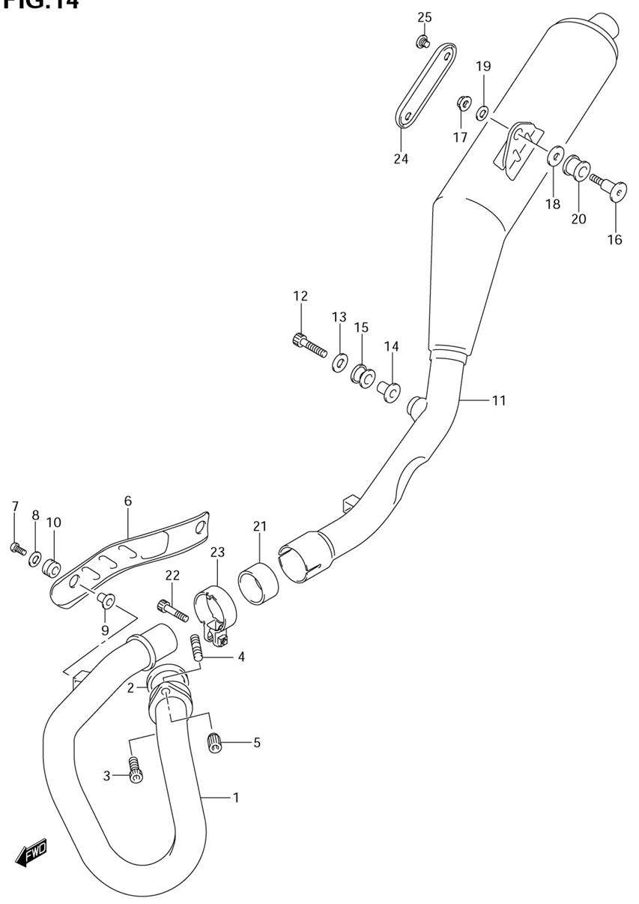

Ref | Description | Qty | SKU | Price (inc vat)
1 | Pipe, Exhaust | 1 | 1415029F10 | € 236,12
2 | Gasket, Exhaust Pipe | 1 | 1418129E02 | € 18,96
3 | Bolt, Speed Rotor | 1 | 071300825B | € 4,18
4 | Bolt, Stud | 1 | 014210816B | € 2,32
5 | Nut | 1 | 0915908112 | € 6,76
6 | Cover, Exhaust Pipe | 1 | 1418029F30 | € 54,12
7 | Screw (6X16) | 2 | 0913906109 | € 3,83
8 | Washer 6.5X18X1 | 2 | 0916006056 | € 1,94
9 | Spacer, Exhaust Pipe Cover | 2 | 1418507G00 | € 3,25
10 | Cushion | 2 | 0932008066 | € 10,11
11 | Body, Muffler | 1 | 1431029F60 | € 698,40
12 | Bolt | 1 | 0910608133 | € 5,18
13 | Washer (8.5X26X1.6) | 1 |  | € -
14 | Spacer | 1 | 0918008151 | € 7,37
15 | Cushion | 1 | 0932012043 | € 9,73
16 | Bolt, Muffler Support Rear | 1 | 1441929F00 | € 13,02
17 | Nut | 1 | 083193108B | € 3,03
18 | Washer,8.5X30X2 | 1 | 0916008503 | € 2,84
19 | Washer | 1 | 083220108B | € 1,97
20 | Cushion | 1 | 0932012048 | € 6,31
21 | Connector | 1 | 1477129F10 | € 27,31
22 | Bolt, Connector | 1 | 071200840B | € 3,45
23 | Clamp, Connector | 1 | 1445929F10 | € 22,86
24 | Cover, Muffler | 1 | 1478229F60 | € 22,68
25 | Screw | 2 | 1478929F01 | € 5,28

Rear fender
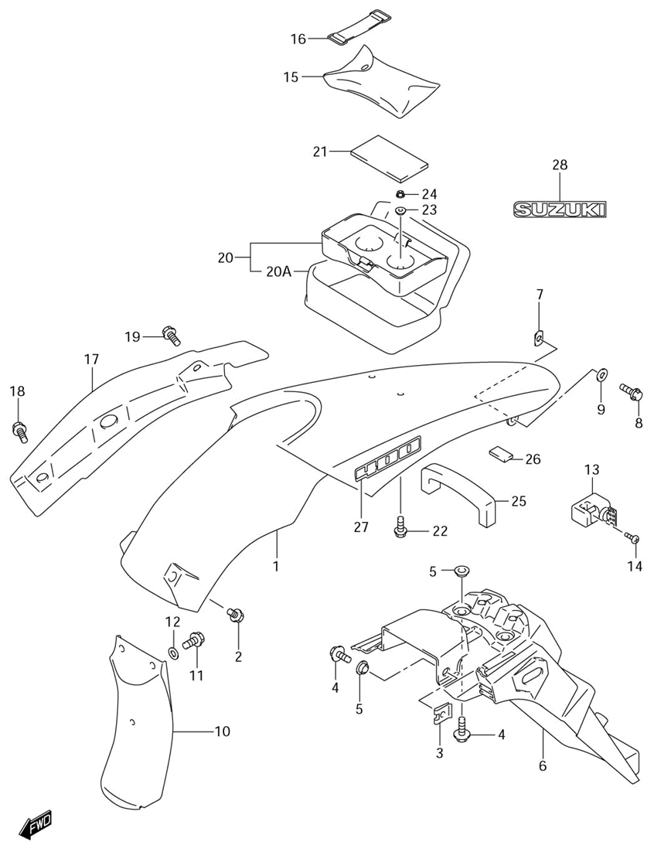

Ref | Description | Qty | SKU | Price (inc vat)
1 | Fender, Rear (Blue) | 1 | 6311329F41YJ4 | € 106,62
1 | Fender, Rear (Yellow) | 1 | 6311329F41YU1 | € 96,58
2 | Bolt | 2 | 0911106066 | € 2,92
3 | Plate, Rear Fender | 2 | 6331213E00 | € 6,83
4 | Bolt, Under Cowl (6X20) | 4 | 0911606115 | € 2,42
5 | Washer | 4 | 0916906073 | € 4,79
6 | Extension, Rear Fender | 1 | 6331129F50 | € 165,55
7 | Nut, Panel & Side | 2 | 9448424F00 | € 5,20
8 | Bolt | 2 | 0155005123 | € 2,70
9 | Washer | 2 |  | € -
10 | Mudguard, Front | 1 | 6341129F00 | € 15,94
11 | Bolt | 2 | 0154706163 | € 2,99
12 | Washer | 2 | 0916906045 | € 2,50
13 | Lock Set, Helmet | 1 | 9570044820 | € 150,92
14 | Screw (6X14) | 1 | 0913906089 | € 3,46
15 | Tool Assy | 1 | 0980021042 | € 30,79
16 | Band, Tool | 1 | 0946200008 | € 4,64
17 | Mudguard, Rear Fender RH | 1 | 6311429F10 | € 21,42
18 | Bolt | 1 | 0911106081 | € 5,63
19 | Bolt | 1 | 6316143E00 | € 2,89
20 | Bag, Seat Tail | 1 | 9490029FA0 | € 94,04
21 | Cushion | 1 | 9491544E00 | € 9,88
22 | Bolt, Front | 2 | 0155006203 | € 2,42
23 | Washer (6.3X17X6) | 2 | 0916906063 | € 4,00
24 | Nut | 2 | 0915906078 | € 3,46
25 | Cushion, Front | 1 | 4716129B00 | € 5,58
26 | Protector (170X95X3.0) | 1 | 3365137000 | € 5,65
27 | Emblem, "400" | 2 | 6817129F10GY8 | € 17,70
27 | Emblem, "400" | 2 | 6817129F10HU8 | € 16,09
28 | Emblem | 1 | 6872113A00GY8 | € 11,77

Front

Front caliper
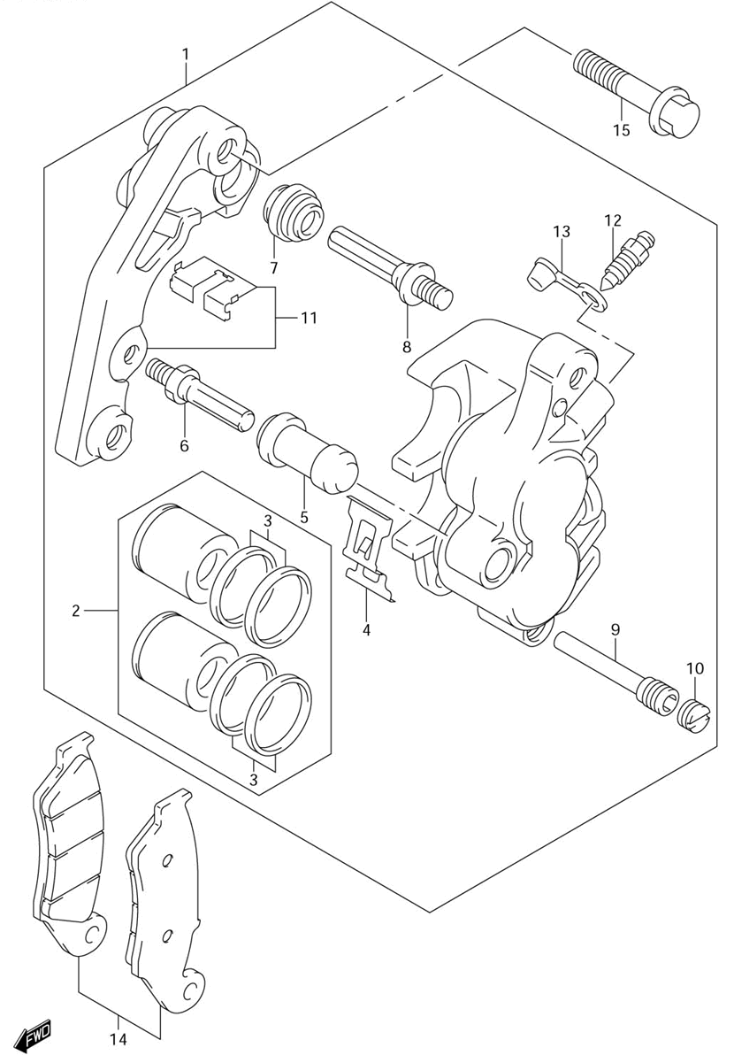

Ref | Description | Qty | SKU | Price (inc vat)
1 | Caliper Assy, Front LH | 1 | 5930013E00999 | € 671,16
2 | Piston Set | 1 | 5930027840 | € 61,87
3 | Seal Set, Piston | 1 | 5930013820 | € 32,78
4 | Spring | 1 | 5931513E00 | € 17,71
5 | Boot | 1 | 5938613A00 | € 7,66
6 | Bolt | 1 | 5938227C30 | € 10,23
7 | Boot | 1 | 5930314500 | € 6,69
8 | Pin | 1 | 5930527C00 | € 18,72
9 | Pin | 1 | 5934513E00 | € 17,74
10 | Plug | 1 | 5914621E10 | € 7,15
11 | Discontinued | 1 | 5935013E00 | € 134,22
12 | Bleeder | 1 | 5912101A00 | € 10,51
13 | Cap | 1 | 5912201A00 | € 5,01
14 | Pad Set | 1 | 5930013860 | € 69,13
15 | Bolt (8X40) | 2 | 0910308338 | € 4,21

Front fender
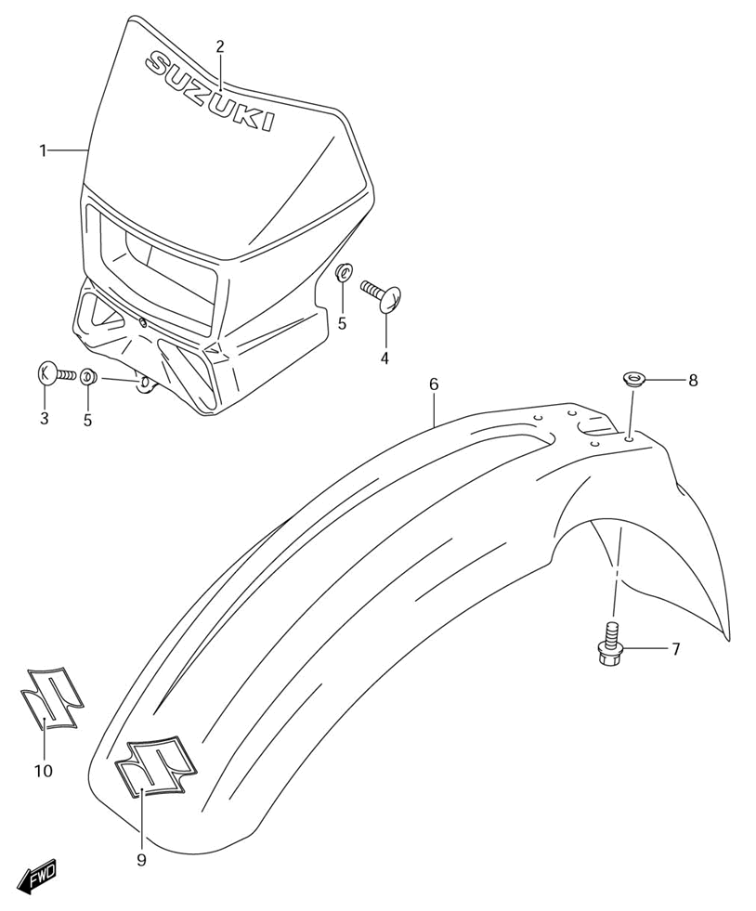
Ref | Description | Qty | SKU | Price (inc vat)
1 | Cover, Head Lamp (White) | 1 | 5181129F1030H | € 99,75
5 | Screw, Lower | 1 | 021420512A | € 1,68
6 | Screw, Front | 2 | 021420612A | € 1,29
7 | Washer | 3 | 0916906033 | € 1,82
8 | Fender, Front (Blue) | 1 | 5311127C22YJ4 | € 119,27
8 | Fender, Front (Yellow) | 1 | 5311127C22YU1 | € 108,16
9 | Bolt | 4 | 0911606170 | € 3,41
10 | Washer | 4 | 0916906073 | € 4,79
11 | Emblem, "S" | 1 | 6815137F00AZT | € 14,40
11 | Emblem, "S" | 1 | 6815137F00BEU | € 14,40

Front master cylinder
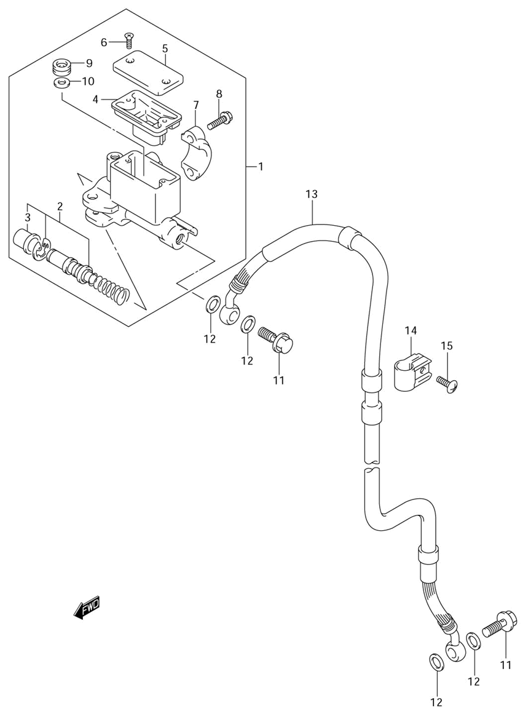

Ref | Description | Qty | SKU | Price (inc vat)
1 | Cylinder Assy, Front Master (Silver) | 1 | 5960044E30 | € 277,91
2 | Piston & Cup Set | 1 | 6960038810 | € 60,29
3 | Boot | 1 | 5966644300 | € 6,85
4 | Diaphragm | 1 | 5966744B00 | € 11,47
5 | Cap | 1 | 5966903D00 | € 23,21
6 | Screw | 2 | 0212204127 | € 2,42
7 | Holder | 1 | 5967103D00 | € 18,79
8 | Bolt | 2 | 5967527C00 | € 3,28
9 | Separator | 1 | 5974836E00 | € 7,19
10 | Ring | 1 | 6974436E00 | € 2,97
11 | Bolt, Fr Caliper | 2 | 0936010062 | € 5,73
12 | Washer (10X15X1.5) | 4 | 0916110009 | € 2,25
13 | Hose, Front Brake | 1 | 5948029F11 | € 351,70
14 | Clamp, Brake Hose | 1 | 5862107A10 | € 4,83
15 | Screw | 1 | 021420625B | € 1,93

Front fork bracket
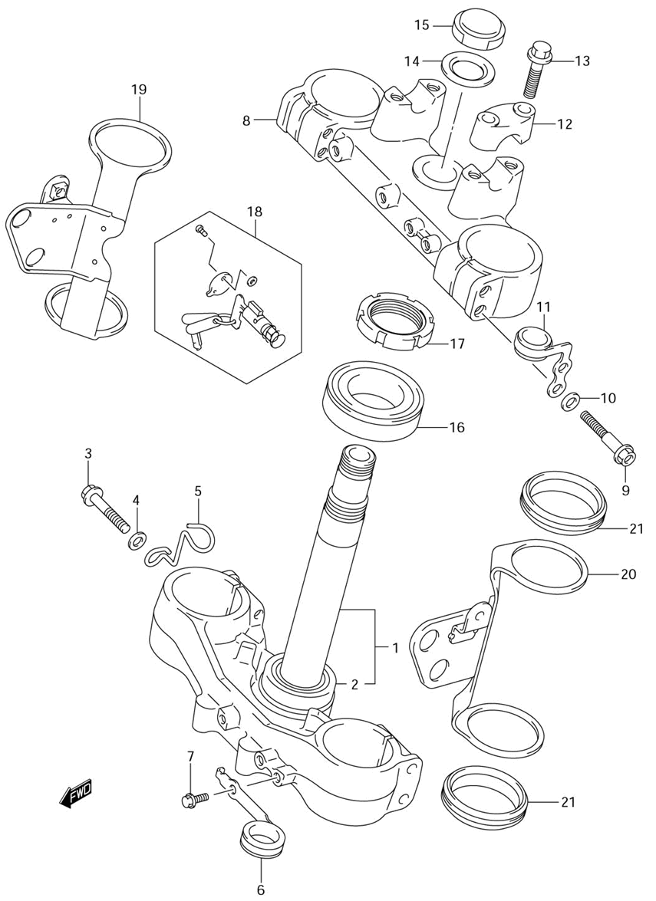

Ref | Description | Qty | SKU | Price (inc vat)
1 | Bracket, Front Fork Under | 1 | 5141029F20 | € 1.089,75
2 | Bearing | 1 | 0926530014 | € 77,13
3 | Bolt, Stem Head | 4 | 5132836E00 | € 6,46
4 | Washer | 4 | 5131636E00 | € 3,20
5 | Guide, Cable | 1 | 3493829E01 | € 11,02
6 | Guide, Hose | 1 | 5145329F20 | € 35,36
7 | Bolt, Protector | 2 | 5862727C40 | € 3,25
8 | Bracket, Front Fork Upper | 1 | 5131129F00 | € 483,64
9 | Bolt, Upper | 4 | 5132829F20 | € 10,03
10 | Washer | 4 | 5131636E00 | € 3,20
11 | Guide, Cable | 1 | 5128829F20 | € 35,36
12 | Holder, Handlebar | 2 | 5621129F00 | € 24,74
13 | Bolt, Handle Holder | 4 | 5132127C40 | € 4,37
14 | Washer, Stem Head | 1 | 5135629E00 | € 17,39
15 | Nut | 1 | 5135329F20 | € 78,77
16 | Bearing | 1 | 0926530014 | € 77,13
17 | Nut, Steering | 1 | 5163128E00 | € 21,15
18 | Discontinued | 1 | 5190030901 | € 211,85
19 | Bracket Comp, Headlamp Hsg R | 1 | 5153029F00 | € 49,96
20 | Bracket Comp, Headlamp Hsg L | 1 | 5154029F00 | € 49,96
21 | Damper, Headlamp Hsg Bracket | 4 | 5155329F00 | € 8,19

Front fork damper
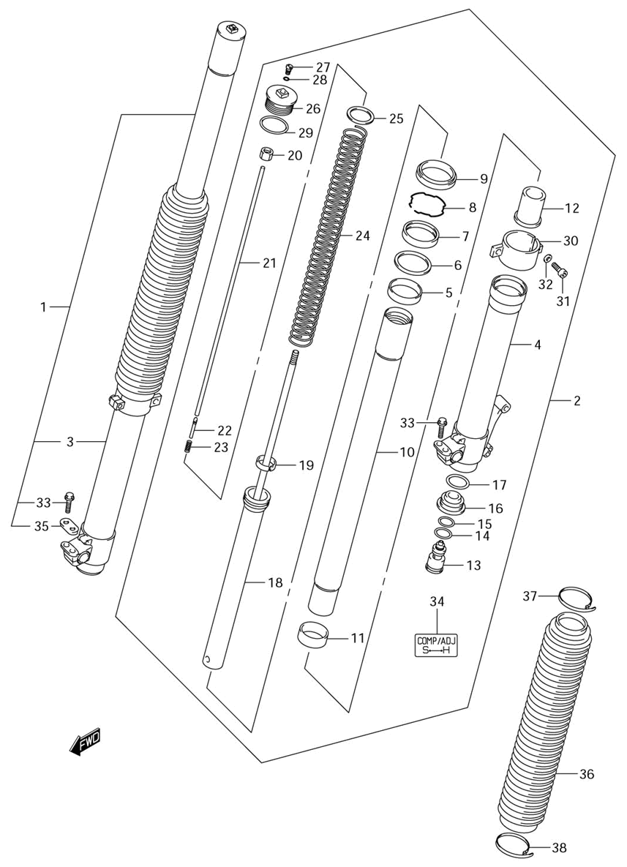

Ref | Description | Qty | SKU | Price (inc vat)
1 | Damper Assy, Front Fork RH | 1 | 5110329F60 | € 3.068,90
2 | Damper Assy, Front Fork LH | 1 | 5110429F60 | € 3.068,90
3 | Tube, Outer RH | 1 | 5113029F60 | € 1.199,42
4 | Tube, Outer LH | 1 | 5114029F60 | € 1.199,42
5 | Bush, Guide | 2 | 5116736E80 | € 20,61
6 | Spacer, Seal | 2 | 5115836E00 | € 6,90
7 | Seal, Oil | 2 | 5115336E00 | € 28,65
8 | Ring, Oil Seal Stopper | 2 | 5115636E00 | € 6,27
9 | Seal, Dust | 2 | 5117336E00 | € 29,63
10 | Tube, Inner | 2 | 5111029F00 | € 897,93
11 | Bush, Slide | 2 | 5112136E40 | € 28,50
12 | Piece, Oil Lock | 2 | 5119529F00 | € 77,94
13 | Bolt, Center | 2 | 5117029F00 | € 298,81
14 | O Ring | 2 | 5117529F00 | € 5,66
15 | O Ring | 2 | 5117429F00 | € 5,66
16 | Plate, End | 2 | 5120529F00 | € 69,38
17 | O Ring, Upper | 2 | 5111727C40 | € 4,75
18 | Rod, Front Damper | 2 | 5119029F00 | € 786,65
19 | Bush, Slide | 2 | 5112229F00 | € 21,33
20 | Nut, Push | 2 | 5182733E00 | € 16,03
21 | Rod, Push | 2 | 5119129F00 | € 19,78
22 | Needle | 2 | 5119205D80 | € 20,29
23 | Spring, Push Rod | 2 | 5119328E00 | € 4,75
24 | Spring, Fr (K=8.63N/0.88 Kg) | 2 | 5117129F60 | € 126,37
25 | Joint, Spring | 2 | 5119236E00 | € 8,05
26 | Bolt, Fork | 2 | 5135129F00 | € 175,43
27 | Bolt, Plug | 2 | 5135728E30 | € 10,60
28 | O Ring, Plug | 2 | 5135828E30 | € 3,25
29 | O Ring, Bolt | 2 | 5111736E00 | € 5,18
30 | Holder, Boot | 2 | 5120329F00 | € 46,64
31 | Bolt | 2 | 0713005207 | € 2,92
32 | Washer | 2 | 0916005044 | € 1,86
33 | Bolt, Handle Holder | 4 | 5132127C40 | € 4,37
34 | Label | 2 | 5114929E40 | € 4,15
35 | Cover, Axle Holder | 1 | 5151629F00 | € 7,60
36 | Boot (Black) | 2 | 5157129F00019 | € 77,74
37 | Band, Boot Upper | 2 | 5157529F00 | € 17,14
38 | Band, Boot Lower | 2 | 5157629F00 | € 15,67

Front wheel
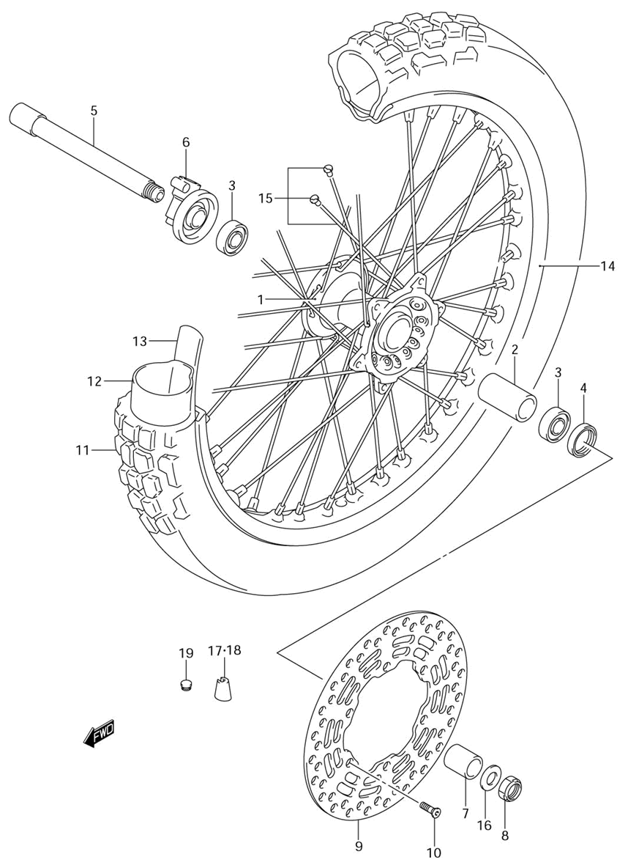

Ref | Description | Qty | SKU | Price (inc vat)
1 | Hub, Front Wheel | 1 | 5411129F10 | € 314,77
2 | Spacer, Front Hub (20.5X27.3X70) | 1 | 5473136E10 | € 18,88
3 | Bearing | 2 | 0813069047 | € 59,29
4 | Oil Seal, LH (25X37X6) | 1 | 0928325083 | € 7,30
5 | Axle, Front | 1 | 5471129F00 | € 96,14
6 | Box Assy, Speedometer Gear | 1 | 5460029F00 | € 99,25
7 | Spacer, Axle LH (L:31) | 1 | 5475136E10 | € 15,92
8 | Nut | 1 | 0915918018 | € 18,60
9 | Disc, Front Brake LH | 1 | 5922113E00 | € 169,85
10 | Screw | 6 | 0912006014 | € 2,99
11 | Tire, Front (80/100-21 51P) | 1 | 5511029F10 | € 138,58
12 | Tube Assy, Wheel Inner | 1 | 5520032E00 | € 44,21
13 | Protector, Inner Tube | 1 | 5526132E00 | € 6,45
14 | Rim, Front Wheel (1.60X21) | 1 | 5531129F00 | € 485,78
15 | Spoke Set, Front Wheel | 1 | 5532029F00 | € 68,05
16 | Washer | 1 | 0916018034 | € 3,39
17 | Balancer, Wheel No.2 | 1 | 5541241F00 | € 6,92
18 | Balancer, Wheel No.2 | 1 | 5541341F00 | € 8,77
19 | Cap | 1 | 0925008013 | € 2,96
20 | Cap, Front Axle LH | 1 | 5471329F00 | € 31,08

Rear

Rear caliper
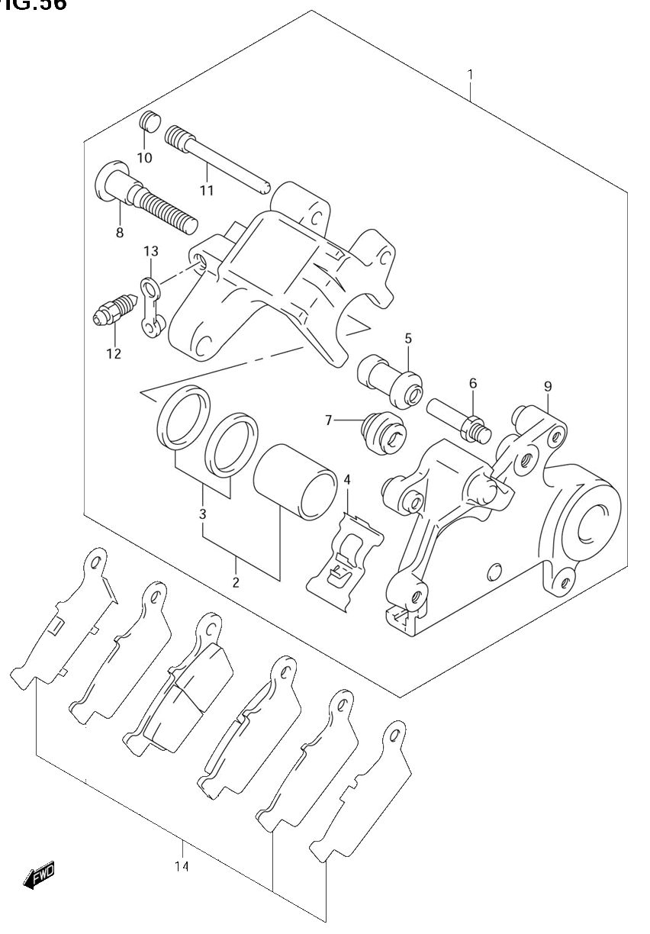
Ref | Description | Qty | SKU | Price (inc vat)
1 | Caliper Assy, Rear | 1 | 6910044E10999 | € 659,73
2 | Piston Set | 1 | 6910043810 | € 47,09
3 | Seal Set, Piston | 1 | 6910036810 | € 18,49
4 | Spring | 1 | 5931536E00 | € 9,03
5 | Boot | 1 | 5938613A00 | € 7,66
6 | Bolt | 1 | 5938227C30 | € 10,23
7 | Boot | 1 | 5930314500 | € 6,69
8 | Pin | 1 | 5930536E00 | € 17,09
9 | Bracket | 1 | 6935136E00 | € 128,75
10 | Plug | 1 | 5914621E10 | € 7,15
11 | Pin | 1 | 6934543D00 | € 10,71
12 | Bleeder | 1 | 5912101A00 | € 10,51
13 | Cap | 1 | 5912201A00 | € 5,01
14 | Pad Set | 1 | 6910036850 | € 69,13

Rear master cylinder
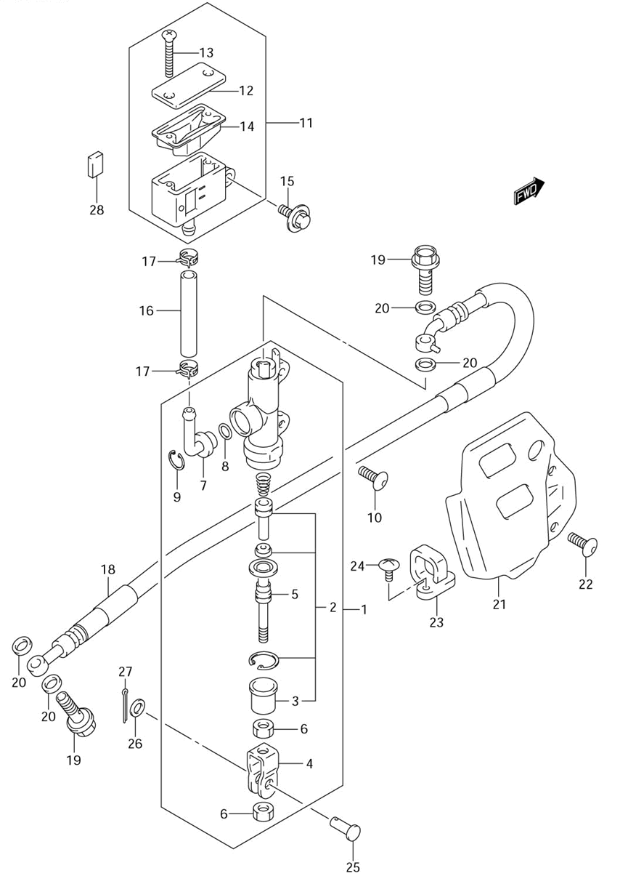

Ref | Description | Qty | SKU | Price (inc vat)
1 | Cylinder Assy, Rear Master | 1 | 6960029F00 | € 232,55
2 | Piston/Cup Set | 1 | 6960004820 | € 57,46
3 | Boot | 1 | 6969100A00 | € 4,87
4 | Yoke | 1 | 6969229F00 | € 20,17
5 | Rod, Push | 1 | 6967036E00 | € 22,29
6 | Nut | 2 | 6969305A00 | € 1,86
7 | Connector | 1 | 6967200B20 | € 6,57
8 | O Ring | 1 | 6968634200 | € 3,47
9 | Circlip | 1 | 6967400B20 | € 3,80
10 | Screw 6X10 | 2 | 0913906067 | € 3,41
11 | Tank Assy, Reservoir | 1 | 6974044E00 | € 54,65
12 | Cap | 1 | 6966944E00 | € 21,33
13 | Screw | 2 | 6968936E00 | € 2,36
14 | Diaphragm | 1 | 5966714500 | € 8,78
15 | Bolt | 1 | 0911606170 | € 3,41
16 | Hose, Reservoir Tank, L:85 | 1 | 5973142E00 | € 12,27
17 | Clamp | 2 | 6973500B20 | € 3,80
18 | Hose, Rear Brake | 1 | 6948029F01 | € 127,31
19 | Bolt, Fr Caliper | 2 | 0936010062 | € 5,73
20 | Washer (10X15X1.5) | 4 | 0916110009 | € 2,25
21 | Guard, Rear Master Cylinder | 1 | 4357136E20 | € 43,38
22 | Screw 6X10 | 2 | 0913906067 | € 3,41
23 | Guide, Brake Hose | 2 | 6119627C30 | € 7,97
24 | Screw, Rear Combination | 2 | 021420510B | € 2,06
25 | Pin | 1 | 0920008048 | € 3,30
26 | Washer (8.5X14X1.6) | 1 | 0916008090 | € 3,57
27 | Pin, Cotter | 1 | 041112015A | € 1,56
28 | Cushion, Tank (9X17X4) | 1 | 6974929F00 | € 4,90

Rear brake
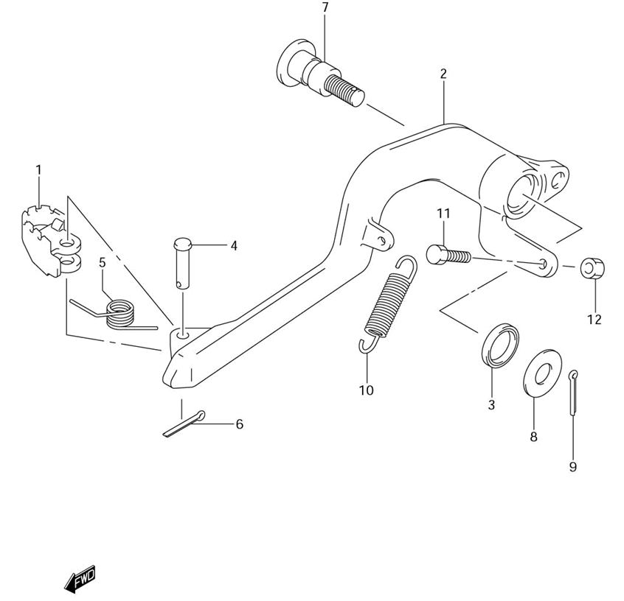
Ref | Description | Qty | SKU | Price (inc vat)
1 | Pedal, Brake | 1 | 4311043D00 | € 9,58
2 | Arm, Brake Pedal | 1 | 4312029F10 | € 248,31
3 | Dust Seal | 2 | 0928415006 | € 4,25
4 | Pin | 1 | 0920006062 | € 3,12
5 | Spring | 1 | 0944411006 | € 4,32
6 | Pin, Cotter | 1 | 041112015A | € 1,56
7 | Shaft | 1 | 4314227C00 | € 21,42
8 | Washer | 1 | 0821110261 | € 3,12
9 | Pin, Cotter | 1 | 041112020A | € 1,56
10 | Spring | 1 | 0944311033 | € 5,51
11 | Bolt, Brake Switch L:30 | 1 | 0910406004 | € 4,45
12 | Nut, Meter Cable No.1 | 1 | 083100006B | € 2,16

Rear cushion lever

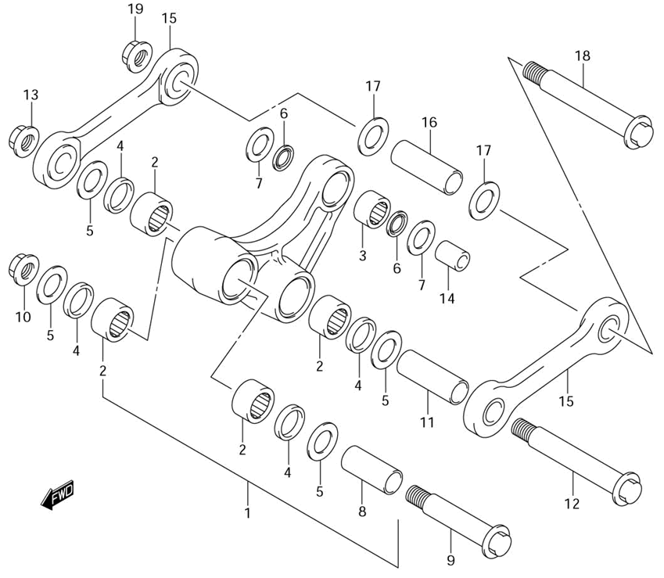

Ref | Description | Qty | SKU | Price (inc vat)
1 | Lever Set, Rear Cushion | 1 | 6260037830 | € 414,30
2 | Bearing (20X27X15) | 4 | 0926320086 | € 19,18
3 | Bearing (16X22X12) | 1 | 0926316033 | € 23,73
4 | Seal, Dust | 4 | 6262414500 | € 5,18
5 | Thrust Washer (20X32.5X1.6) | 4 | 6264737E00 | € 3,84
6 | Oil Seal,16X22X | 2 | 0928416005 | € 6,29
7 | Thrust Washer (16X28.5X1.6) | 2 | 6268537E00 | € 3,84
8 | Spaceer, Front (15X20X45) | 1 | 6231737E10 | € 17,50
9 | Bolt, Front (12X76) | 1 | 6265837E01 | € 13,91
10 | Nut | 1 | 0915912056 | € 9,04
11 | Spacer, Rod (15X20X57.4) | 1 | 6264637E10 | € 17,50
12 | Bolt, Rod (12X100) | 1 | 6262137E01 | € 16,83
13 | Nut | 1 | 0915912056 | € 9,04
14 | Spacer, Rear (10X16X22) | 1 | 6268436E10 | € 10,98
15 | Rod, Rear Cushion Lever | 2 | 6264037E11 | € 176,04
16 | Spacer, Rod (15X20X57.4) | 1 | 6264637E10 | € 17,50
17 | Thrust Washer (20X32.5X1.6) | 2 | 6264737E00 | € 3,84
18 | Bolt, Rod (12X100) | 1 | 6262137E01 | € 16,83
19 | Nut | 1 | 0915912056 | € 9,04

Rear shock absorber
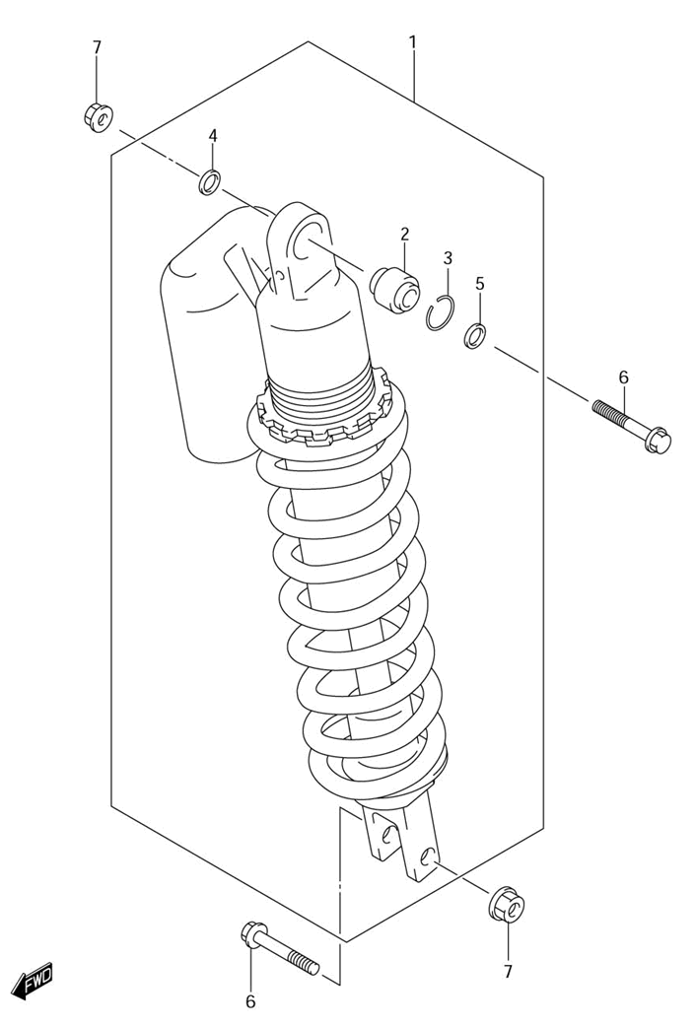
Ref | Description | Qty | SKU | Price (inc vat)
1 | Absorber Assy, Rear Shock (Yellow) | 1 | 6210029F80163 | € 2.509,37
1 | Absorber Assy, Rear Shock (White) | 1 | 6210029F8028W | € 2.485,86
2 | Bearing (10X26X22) | 1 | 6217536E00 | € 83,09
3 | Stop Ring | 1 | 6227727C40 | € 2,85
4 | Seal, Dust RH | 1 | 6222636E00 | € 7,30
5 | Seal, Dust LH | 1 | 6222636E10 | € 7,30
6 | Bolt (10X47.5) | 2 | 0910310149A05 | € 0,24
7 | Nut | 2 | 0915910115 | € 4,29

Rear swing arm
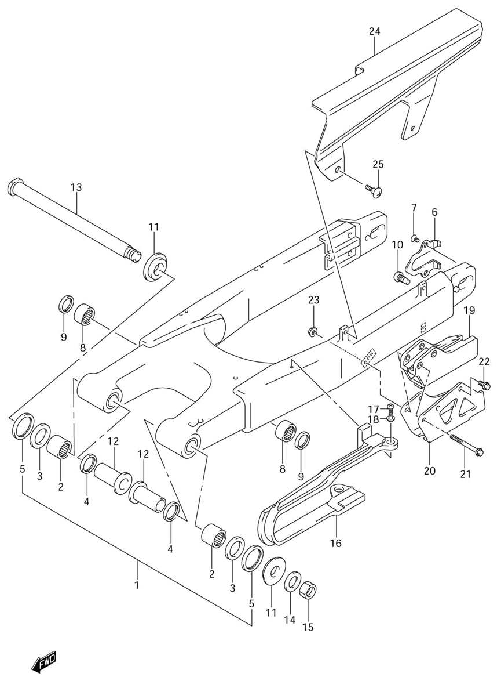

Ref | Description | Qty | SKU | Price (inc vat)
1 | Swinging Arm Assy, Rear | 1 | 6100029F10 | € 1.852,68
2 | Bearing, Pivot (22X29X30) | 2 | 0926322017 | € 30,68
3 | Bearing, Outer (22X35X2) | 2 | 0926322064 | € 26,41
4 | Oil Seal (22X29X4) | 2 | 0928522001 | € 6,35
5 | Seal, Outer (29.2X37X4) | 2 | 6126236E00 | € 6,27
6 | Plate | 1 | 6112829E00 | € 15,83
7 | Screw, 5X8 | 2 | 0912605009 | € 3,11
8 | Bearing (20X27X15) | 2 | 0926320086 | € 19,18
9 | Seal, Dust | 2 | 6262414500 | € 5,18
10 | Bolt, Stopper (10X17) | 2 | 6143113E00 | € 10,41
11 | Spacer, Pivot Outer | 2 | 6125044E00 | € 17,58
12 | Spacer, Pivot Inner | 2 | 6125236E00 | € 38,41
13 | Shaft, Pivot | 1 | 6121129F00 | € 77,42
14 | Washer | 1 | 083220116B | € 2,40
15 | Nut | 1 | 0915916007 | € 15,62
16 | Buffer, Chain Touch Defense | 1 | 6127329F00 | € 73,14
17 | Screw | 3 | 021120508B | € 2,14
18 | Washer | 3 | 0916905022 | € 4,28
19 | Guide, Chain | 1 | 6134137F00 | € 68,35
20 | Plate, Guide Outer | 1 | 6134236E30 | € 48,35
21 | Bolt, Upper | 2 | 015470650B | € 3,25
22 | Bolt | 1 | 015470612B | € 2,99
23 | Nut | 2 | 083193106B | € 2,66
24 | Case, Chain | 1 | 6131034E00 | € 95,34
25 | Screw (6X16) | 2 | 0913906083 | € 2,73

Rear wheel
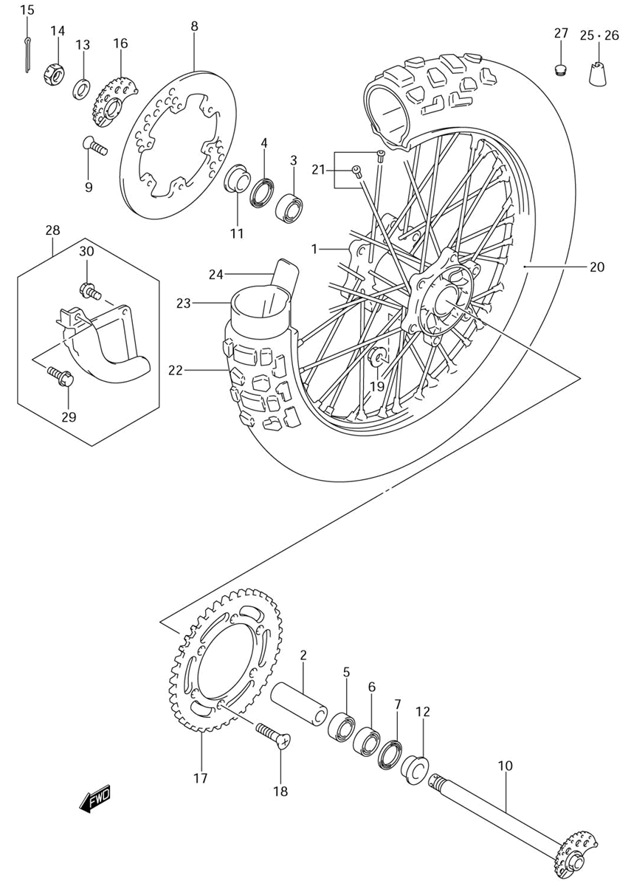

Ref | Description | Qty | SKU | Price (inc vat)
1 | Hub, Rear Wheel | 1 | 6411129F10 | € 541,24
2 | Spacer, Bearing | 1 | 6473129F00 | € 30,53
3 | Bearing | 1 | 0813360047 | € 34,84
4 | Seal, Hub Bearing Dust (29X42X6) | 1 | 6484128E00 | € 11,85
5 | Bearing | 1 | 0813360047 | € 34,84
6 | Bearing,20X47X1 | 1 | 0812362047A00 | € 32,13
7 | Seal, LH (29X47X5) | 1 | 0928329006 | € 13,72
8 | Disc, Rear Brake | 1 | 6921143D00 | € 240,76
9 | Screw | 6 | 0912006014 | € 2,99
10 | Axle, Rear | 1 | 6471029F00 | € 140,10
11 | Spacer, LH | 1 | 6475128E20 | € 24,54
12 | Spacer, RH | 1 | 015500612B | € 18,46
13 | Washer | 1 | 0916019022 | € 5,89
14 | Nut | 1 | 083192118A | € 5,54
15 | Adjuster, Chain RH | 1 | 6141029F00 | € 22,79
16 | Sprocket, Rear (Nt:44- 520) | 1 | 6451114D80 | € 61,98
17 | Screw | 6 | 0912008010 | € 2,73
19 | Rim, Rear Wheel (2.15X18) | 1 | 6531129F00 | € 492,57
20 | Spoke Assy, Rear Wheel | 1 | 6532029F00 | € 80,72
21 | Tire, Rear (120/90-1 | 1 | 6511029F10 | € 197,91
22 | Tube Assy, Wheel Inner | 1 | 6520029E00 | € 51,11
23 | Protector, Inner Tube | 1 | 6526114E00 | € 8,33
24 | Balancer, Wheel No.2 | 1 | 5541241F00 | € 6,92
25 | Balancer, Wheel No.2 | 1 | 5541341F00 | € 8,77
26 | Cap | 1 | 0925008013 | € 2,96
27 | Cover Set, Rear Disc | 1 | 6920028C00 | € 21,81
28 | Bolt, Set | 1 | 015500620B | € 2,70
29 | Bolt, Bracket | 1 | 015500612B | € 2,89

Cockpit

Speedometer
1
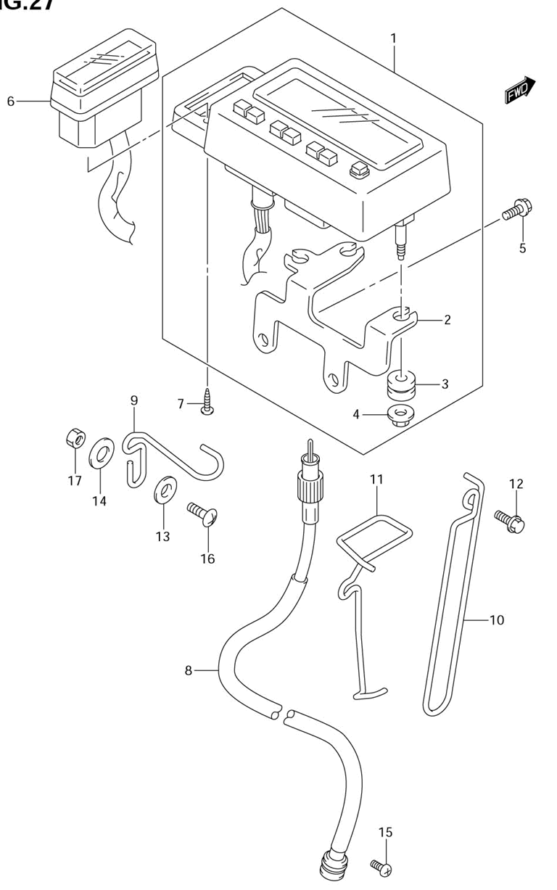

Ref | Description | Qty | SKU | Price (inc vat)
1 | Speedometer Assy (Kilo) | 1 | 3410029F01 | € 1.796,94
1 | Speedometer Assy (Mile/Kilo) | 1 | 3410029F21 | € 1.760,89
2 | Bracket | 1 | 3495029F00 | € 44,70
3 | Cushion | 2 | 3499643410 | € 4,18
4 | Nut, Rear Rr | 1 | 083161005A | € 2,67
5 | Bolt | 2 | 015500616B | € 2,93
6 | Box Assy, Pilot Lamp | 1 | 3638029F00 | € 272,85
7 | Screw | 2 | 035110420B | € 2,51
8 | Cable, Speedometer | 1 | 3491032E00 | € 41,01
9 | Guide, Meter Cable No.1 | 1 | 3493803D22 | € 11,02
10 | Guide, Meter Cable No.2 | 1 | 3493814D30 | € 12,05
11 | Guide, Meter Cable No.3 | 1 | 3493829F10 | € 13,57
12 | Bolt | 1 | 0911606167 | € 2,52
13 | Washer (6.5X18X1.6) | 1 | 0916006109 | € 2,25
14 | Washer | 1 | 0916906054 | € 2,32
15 | Screw | 1 | 021120516B | € 2,14
16 | Screw | 1 | 021420616B | € 2,06
17 | Nut, Meter Cable No.1 | 1 | 083100006B | € 2,16

Handle switch
Ref | Description | Qty | SKU | Price (inc vat)

Handlebar
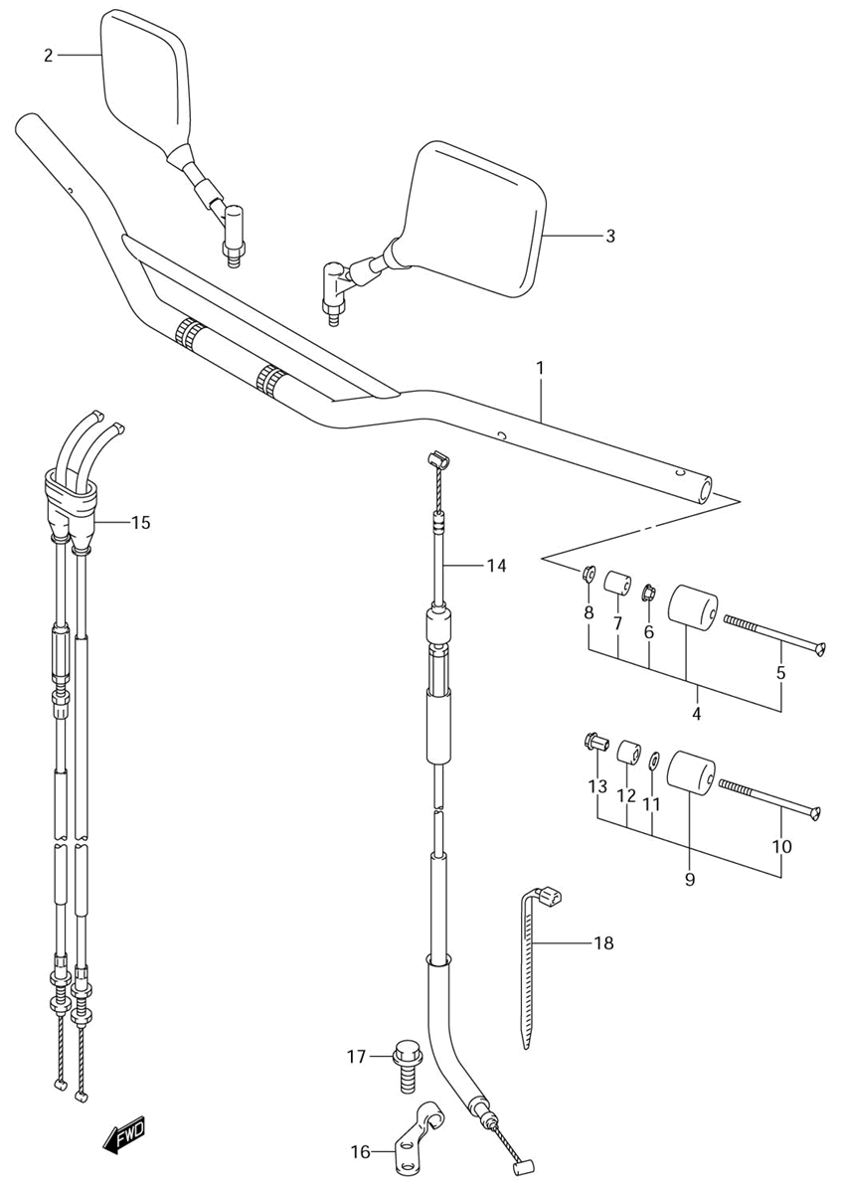

Ref | Description | Qty | SKU | Price (inc vat)
1 | Handlebar (Silver) | 1 | 5611029F1013L | € 134,84
2 | Mirror Assy, Rear View RH | 1 | 5650006G10 | € 112,60
3 | Mirror Assy, Rear View LH | 1 | 5660006G10 | € 112,60
4 | Balancer Set | 2 | 5620032821 | € 23,02
5 | Screw | 2 | 0212206803 | € 3,46
6 | Nut | 2 | 0831610083 | € 2,73
7 | Expander | 2 | 5627244500 | € 4,37
8 | Nut | 2 | 0915906024 | € 2,40
14 | Cable, Clutch | 1 | 5820029F10 | € 53,31
15 | Cable Assy, Throttle | 1 | 5830129F10 | € 91,79
16 | Stopper, Cable | 1 | 5863429F00 | € 12,05
17 | Bolt | 2 | 0910306092 | € 2,55
18 | Clamp (L:235) | 2 | 0940725401 | € 5,34
18 | Clamp | 1 | 0940714407 | € 4,44
18 | Clamp | 1 | 0940710404 | € 2,86

Left handle lever
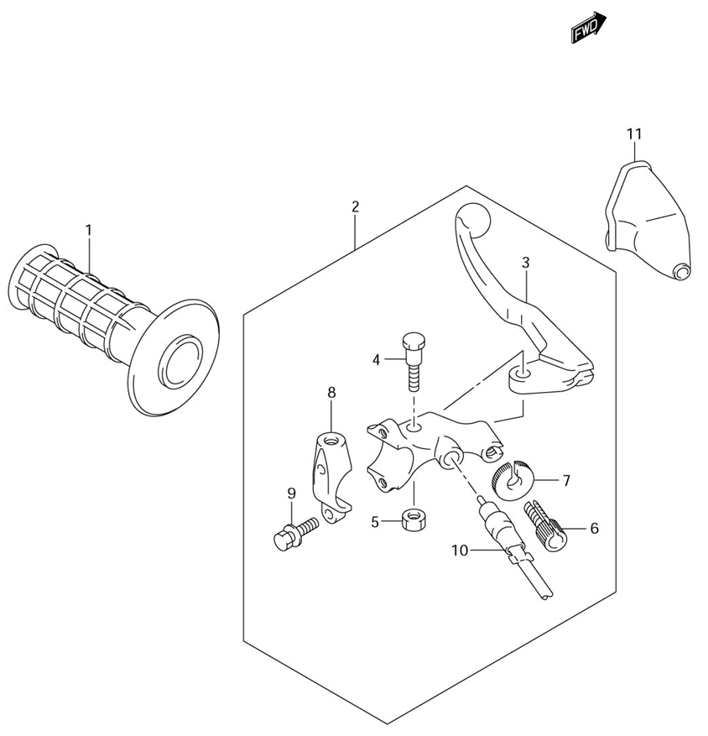
Ref | Description | Qty | SKU | Price (inc vat)
1 | Grip, LH | 1 | 5721112D00 | € 17,36
2 | Lever Assy, Clutch | 1 | 5750029F01 | € 78,05
3 | Lever, Clutch | 1 | 5762113E00 | € 29,29
4 | Bolt, Lever Pivot | 1 | 5743121D11 | € 11,20
5 | Nut | 1 | 0831921068 | € 2,38
6 | Adjuster, Wire | 1 | 5744129F00 | € 12,15
7 | Nut | 1 | 5744245C00 | € 10,29
8 | Bracket, Holder | 1 | 5751213E00 | € 20,92
9 | Bolt, Bracket | 2 | 5751313E00 | € 5,09
10 | Switch Assy, Clutch | 1 | 5756013E00 | € 23,92
11 | Dust Cover, Clutch Cable | 1 | 5734129F01 | € 11,21

Right handle lever
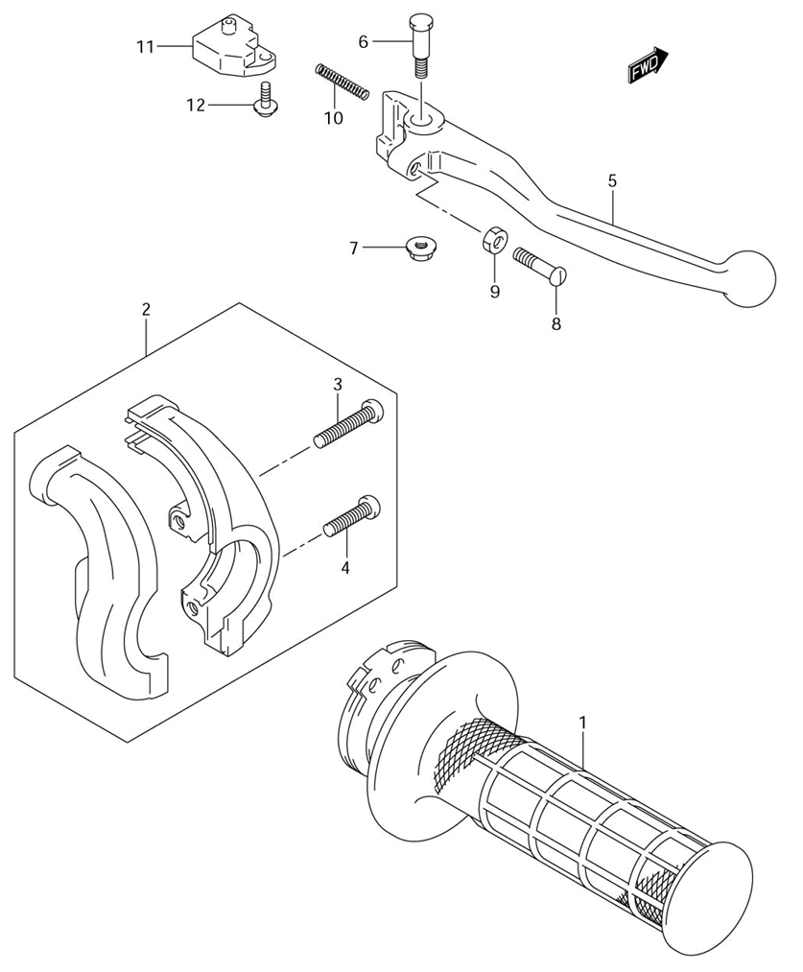
Ref | Description | Qty | SKU | Price (inc vat)
1 | Grip, Throttle | 1 | 5711012D11 | € 43,67
2 | Case Assy, Throttle | 1 | 5710014D00 | € 83,68
3 | Screw, Upper | 1 | 0912505066 | € 2,05
4 | Screw | 1 | 021120520B | € 2,06
5 | Lever, Brake | 1 | 5742144E00 | € 23,88
6 | Bolt | 1 | 5743114500 | € 5,79
7 | Nut | 1 | 083192106A | € 2,38
8 | Screw | 1 | 5743114511 | € 5,39
9 | Nut | 1 | 083100005A | € 1,77
10 | Spring | 1 | 5731814502 | € 4,03
11 | Switch Assy, Stop | 1 | 5746017C11000 | € 44,27
12 | Screw | 1 | 5746517C00 | € 1,91

Other

Gasket set
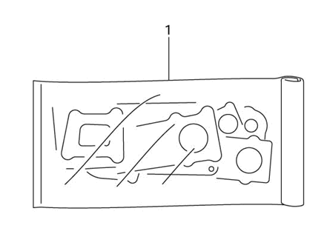
Ref | Description | Qty | SKU | Price (inc vat)
1 | Gasket Set | 1 | 1140129882 | € 169,09
1 | Gasket, Cylinder Head | 1 | 1114129F01 | € 46,65
1 | Gasket | 1 | 1117329F00 | € 33,45
1 | Gasket, Cylinder | 1 | 1124129F11 | € 26,10
1 | Gasket, Clutch Cover | 1 | 1148229F00 | € 25,49
1 | O Ring (D:2.6,Id:69.6) | 1 | 0928071004 | € 25,18
1 | O Ring, Clutch Cover Outer | 1 | 1148429F00 | € 24,58
1 | Gasket, Exhaust Pipe | 1 | 1418129E02 | € 18,96
1 | Gasket, Magneto Cover | 1 | 1148329F00 | € 15,65
1 | Washer | 2 | 0916111008 | € 5,63
1 | O Ring, (D:2.4,Id:11.0) | 2 | 0928011005 | € 5,29
1 | O Ring D:2.4 Id | 1 | 0928054001 | € 4,84
1 | Gasket, Adjuster | 1 | 1283724A10 | € 4,14
1 | O Ring D:1.9 Id | 1 | 0928013004 | € 2,75
1 | O Ring (D:3.1,Id:32.7) | 1 | 0928033004 | € 2,75
1 | O Ring D:3.1 Id | 1 | 0928017003 | € 2,05

Label
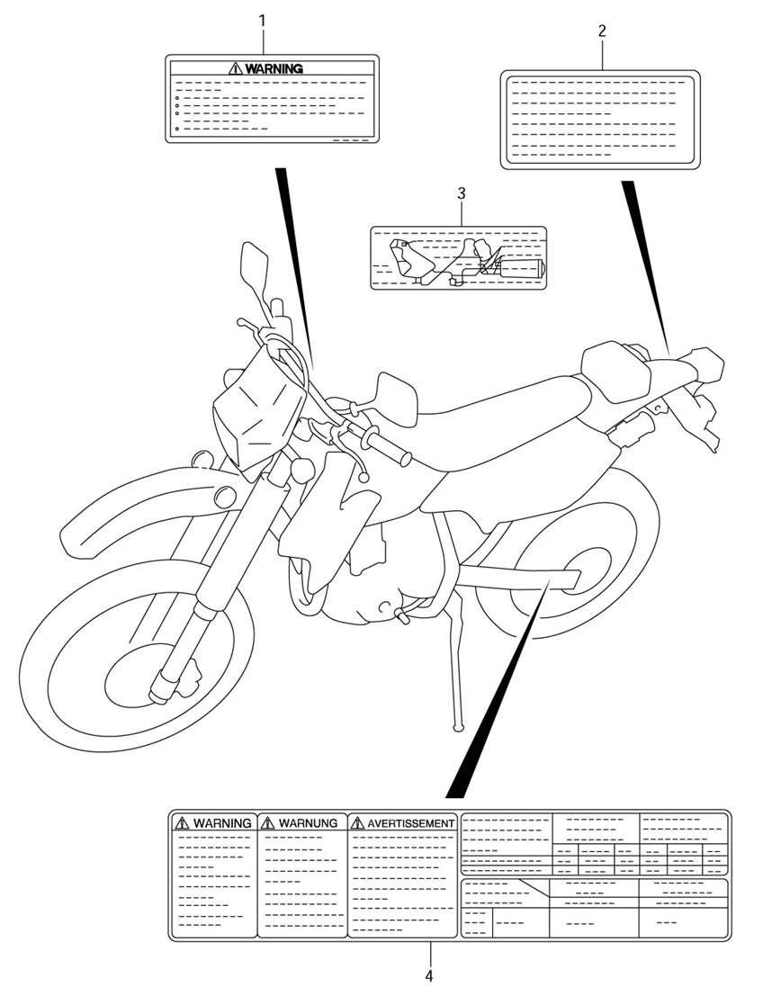

Ref | Description | Qty | SKU | Price (inc vat)
1 | Label, Warning (Italian) | 1 | 6831930F40 | € 12,87
1 | Label, Warning (Swedish) | 1 | 6831930F90 | € 12,68
1 | Label, Warning (German) | 1 | 6831929F20 | € 9,79
1 | Label, Warning (Dutch) | 1 | 6831929F70 | € 9,79
1 | Label, Warning (Danish) | 1 | 6831929FC0 | € 9,79
1 | Label, Warning (Potuguese) | 1 | 6831929F80 | € 9,65
1 | Label, Warning (English) | 1 | 6831929F00 | € 9,23
1 | Label, General Warning | 1 | 6831829F01 | € 9,14
1 | Label, Warning (French) | 1 | 6831929F30 | € 7,18
1 | Label, Warning (Finnish) | 1 | 6831929FA0 | € 7,18
1 | Label, Warning (Italian) | 1 | 6831929F40 | € 6,46
1 | Label, Warning (Spanish) | 1 | 6831929F50 | € 6,46
1 | Label, Warning (Swedish) | 1 | 6831929F90 | € 6,46
1 | Label, Warning (Norwegian) | 1 | 6831929FB0 | € 6,46
2 | Label, Caution Fuel | 1 | 6862317D00 | € 4,57
2 | Label, Fuel | 1 | 8693273060 | € 3,70
3 | Label, Tire | 1 | 6833229F11 | € 9,98

Optional
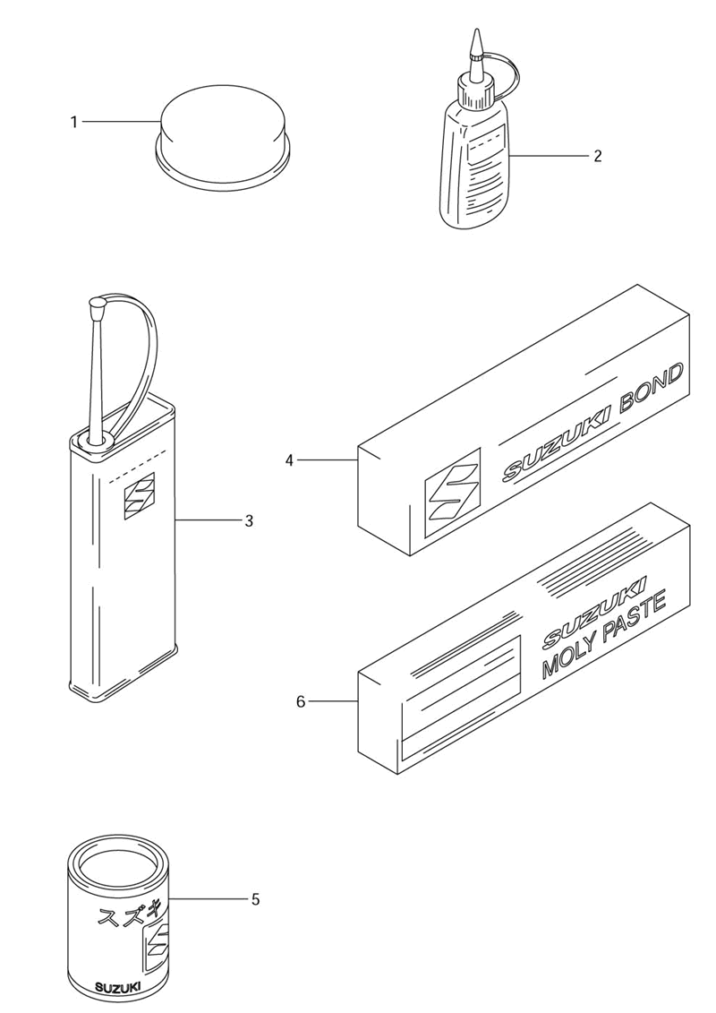

Ref | Description | Qty | SKU | Price (inc vat)
1 | Brake Pad Grease (Pbc) | 1 | 9900025110 | € 37,40
2 | Discontinued | 1 | 9900032100 | € 43,21
2 | Thread Lock, Super (1360) | 1 | 9900032130 | € 37,15
2 | Thread Lock, Super (1342) | 1 | 9900032050 | € 21,81
2 | Discontinued | 1 |  | € -
3 | Cement, Thread Lock | 1 | 9900032040 | € 59,75
4 | Discontinued | 1 | 9900031110 | € 59,75
4 | Discontinued | 1 | 9900031140THR | € 29,92
5 | Grease, Super | 1 | 9900025030 | € 6,62
6 | Suzuki Moly Paste | 1 | 9900025140 | € 8,52
7 | Paint (Sonic Silver Metallic) | 1 | 9900010209YD8 | € 55,68
7 | Paint (Bright Silver Metallic) | 1 | 990001020913L | € 46,36
7 | Paint (Grank Blue Metallic) | 1 | 9900010209YC2 | € 46,36
7 | Paint (Black) | 1 | 9900010109019 | € 25,22
7 | Discontinued | 1 |  | € -
7 | Paint (Light Charcoal Metallic) | 1 | 990001020924K | € -

